Microsoft Cloud Workshops

Internet of Things Lab Guide

February 2017

© 2017 Microsoft Corporation. All rights reserved. This document is confidential and proprietary to Microsoft. Internal use only. This document is for informational purposes only. MICROSOFT MAKES NO WARRANTIES, EXPRESS OR IMPLIED, IN THIS SUMMARY.

This document is provided "as-is." Information and views expressed in this document, including URL and other Internet Web site references, may change without notice. You bear the risk of using it.

Some examples are for illustration only and are fictitious. No real association is intended or inferred.

## Contents

Internet of Things (IoT) hackathon 1

Internet of Things hackathon answers 11

# Internet of Things (IoT) hackathon

## Overview

Fabrikam provides services and smart meters for enterprise energy (electrical power) management. There *You-Left-The-Light-On* service enables the enterprise to understand their energy consumption.

In this Hackathon, you will construct an end-to-end solution for an IoT scenario that includes device management; telemetry ingest; hot and cold path processing; and reporting.

## Requirements

* Microsoft Azure subscription must be pay-as-you-go or MSDN.
  + Trial subscriptions will *not* work.
* Local machine or a virtual machine configured with:
  + Visual Studio 2015 Community Edition or later
  + Azure SDK 2.8.2 for Visual Studio
  + Azure PowerShell 1.0.0 or later
* A running HD Insight Spark cluster (see Exercise 0).

## Exercise 0: Before the Hackathon

Duration: 60 minutes

Synopsis: You should follow all of the steps provided in Exercise 0 of the Proctor Guide (included in this document) *before* attending the Hackathon.

### Task 1: Provision Power BI

1. If you do not already have a Power BI account, go to <https://www.powerbi.com>.
2. On the page, enter your work email address (which should be the same account as the one you use for your Azure subscription) and click **Use it free**.

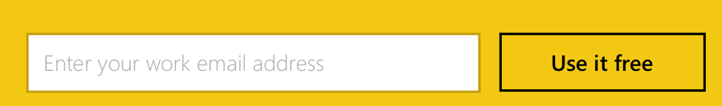

1. Follow the on-screen prompts and your Power BI environment should be ready within minutes. You can always return to it via <https://app.powerbi.com>.

### Task 2: Provision an HDInsight with Spark Cluster

Using the Azure Portal, provision a new HDInsight cluster.

1. Select **+New**, select **Intelligence + Analytics**, **HDInsight**

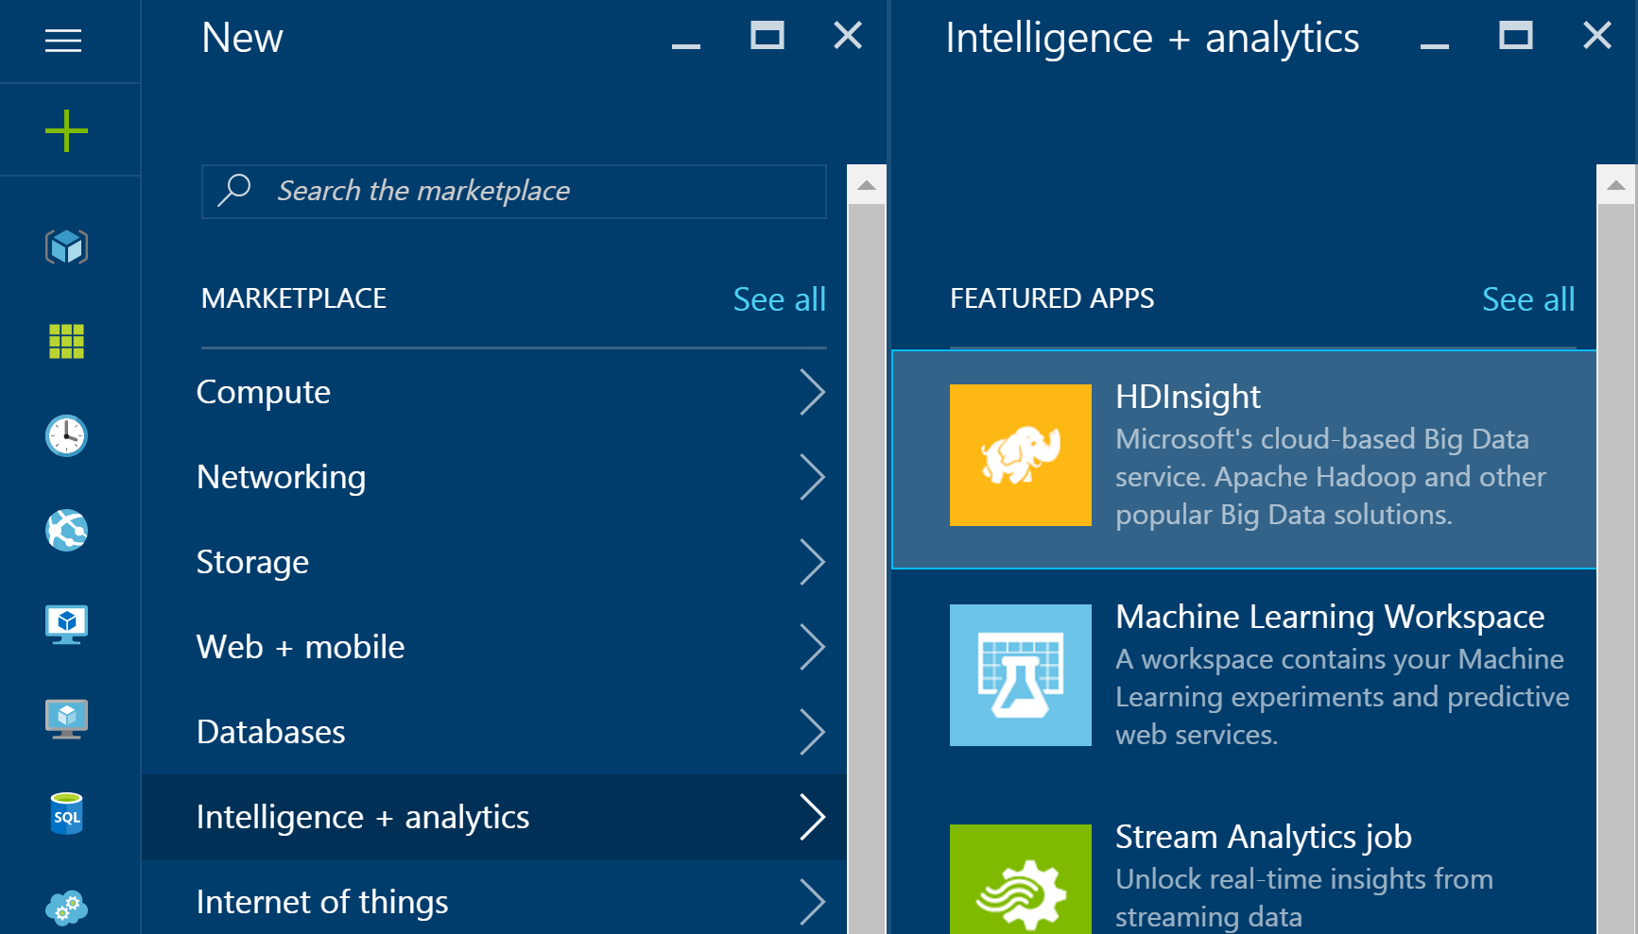

1. Provide a unique Cluster Name.
2. Select **Subscription**.
3. Choose the Azure Subscription into which you want to deploy the cluster.
4. Select **Cluster Type**.
5. Set the **Cluster Type** to **Spark** and the **Version** to **1.6.2** (or later). Note that the Operating System option for the Spark cluster is fixed to Linux.
6. Select the **Standard** tier.  
   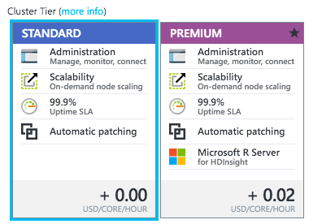
7. Click **Select**.
8. Click **Credentials**.
9. Leave Cluster Login Username as admin, set a Cluster Login Password and Confirmation. Also set an SSH username and password. Leave SSH Authentication Type set to Password.

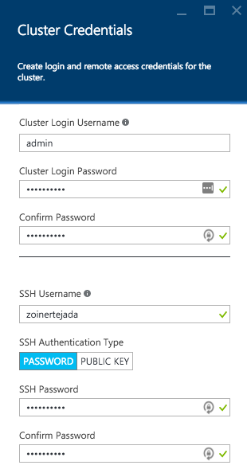

1. Click **Select**.
2. Click **Data Source**.
3. Leave Selection Method at From all subscriptions, then choose or create a new storage account.

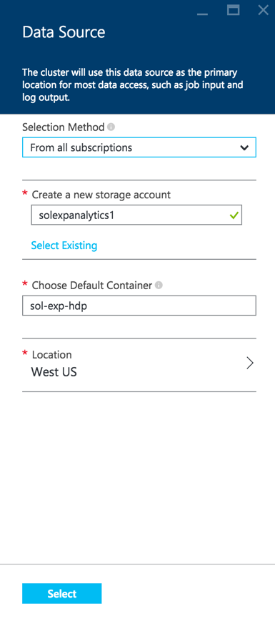

1. Set the Choose Default Container to the name of your cluster.

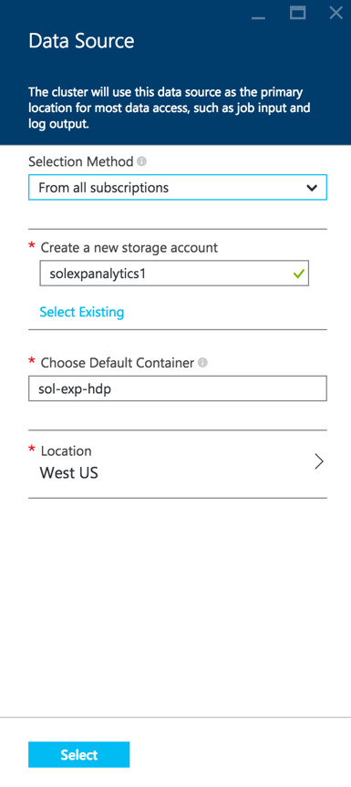

1. Ensure that the location is set to the same as other demo resources.

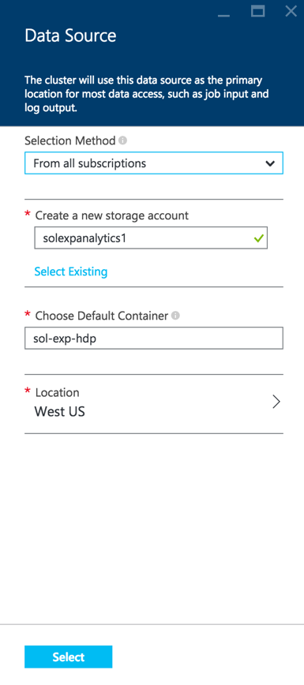

1. Click **Select**.
2. Click **Pricing**.

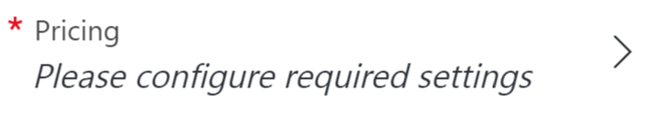

1. Leave the number of Worker Nodes at **4.**
2. Select **Worker node size**, click **D12 v2** and click **Select**.
3. Select **Head node size**, click **D12 v2** and click **Select**.

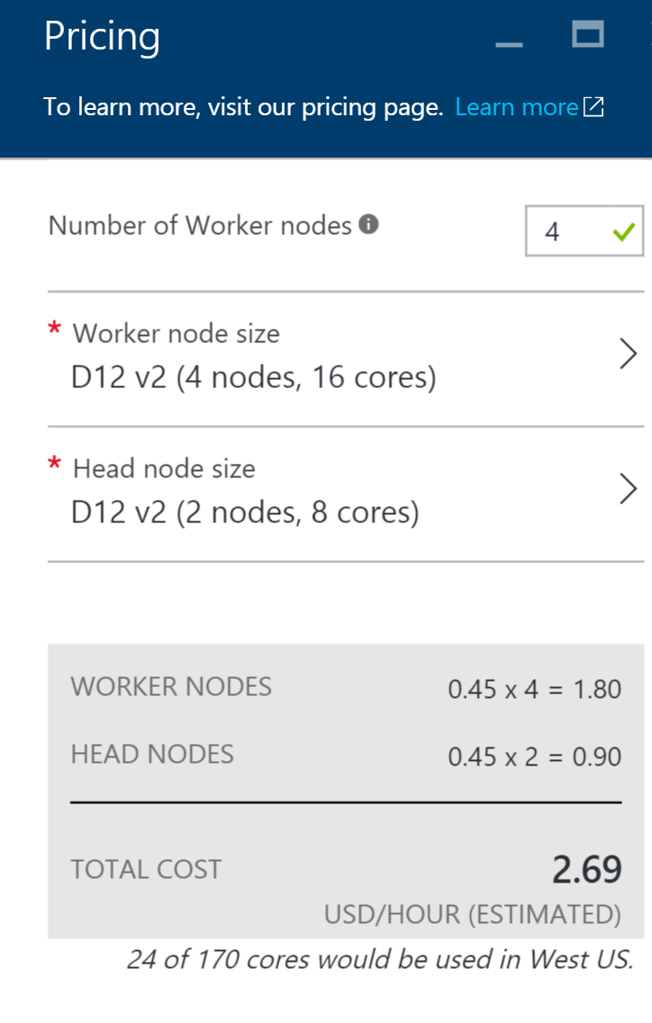

1. Select **Resource Group** and create a new Resource Group called **Hackathon**.  
   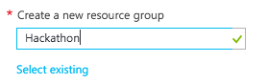
2. On the New HDInsight Cluster blade, click **Create**. Your cluster should be ready within 30 minutes.

## Exercise 1: Environment setup

Duration: 10 minutes

Fabrikam has provided a Smart Meter Simulator that they use to simulate device registration as well as the generation and transmission of telemetry data. They have asked you to use this as the starting point for integrating their smart meters with Azure.

### Task 1: Download and open the Smart Meter Simulator

1. Download the Smart Meter Simulator starter project from the following URL:  
   <http://bit.ly/1KR8TPY>. (Note: the URL is case-sensitive)
2. Unzip the contents.
3. Open SmartMeterSimulator.sln with Visual Studio.

**Note:** If you attempt to build the solution at this point, you will see many build errors. This is intentional. You will correct these in the exercises that follow.

## Exercise 2: IoT Hub provisioning

Duration: 20 minutes

In your architecture design session with Fabrikam, it was agreed that you would use an Azure IoT Hub to manage both the device registration and telemetry ingest from the Smart Meter Simulator. Your team also identified the Microsoft provided Device Explorer project that Fabrikam can use to view the list and status of devices in the IoT Hub registry.

### Task 1: Provision an IoT Hub

### Tasks to complete

* Provision an IoT Hub.
* Determine and take note of the connection strings required for 1) full control and 2) read/write access to the device registry.

### Exit criteria

* You have an IoT Hub provisioned in your Azure subscription.
* You have properly selected the connection strings having appropriate permissions.

### Task 2: Configure the Smart Meter Simulator

### Tasks to complete

* Edit the Fabrikam Smart Meter Simulator so that the IoT connection string text box has a value of your connection string to the IoT Hub having full permissions.

### Exit criteria

* Your connection string should now be present every time you run the Smart Meter Simulator (in subsequent steps).

### Task 3: Download and configure the Device Explorer

### Tasks to complete

* Download the Azure IoT SDK from: <https://github.com/Azure/azure-iot-sdks>.
* Within the download, locate the DeviceExplorer.sln solution and open it within Visual Studio.
* Build and run the DeviceExplorer project.
* Provide your IoT connection string to DeviceExplorer.

### Exit criteria

* Verify that on the **Management** tab you can list the currently registered devices. You should have 0 devices at this point.

## Exercise 3: Completing the Smart Meter Simulator

Duration: 90 minutes

Fabrikam has left you a partially completed sample in the form of the Smart Meter Simulator solution. You will need to complete the missing lines of code that deal with device registration management and device telemetry transmission that communicate with your IoT Hub.

### Task 1: Implement device management with the IoT Hub

### Tasks to complete

* In the solution, open **DeviceManager.cs** and complete the lines of code below each of the TODO comments.

### Exit criteria

* There are 16 TODOs in this file and you should have completed all of them. You can use the Task List to see all of the tasks at a glance. From the **View** menu, click **Task List**. There you will see a list of TODO tasks, where each task represents one line of code that needs to be completed.

### Task 2: Implement the communication of telemetry with the IoT Hub

### Tasks to complete

* In the solution, open **Sensor.cs** and complete the lines of code below each of the TODO comments.

### Exit criteria

* There are four TODOs in this file and you should have completed all of them. You can use the Task List to see all of the tasks at a glance. From the **View** menu, click **Task List**. There you will see a list of TODO tasks, where each task represents one line of code that needs to be completed.

### Task 3: Verify Device Registration and Telemetry

### Tasks to complete

* Build and run the Smart Meter Simulator.
* Register all devices.
* By clicking on 1–10 of the windows within the building in the app, select the devices to install (they should turn yellow) and then activate them (after which they turn green).
* Use Device Explorer to view the list of registered devices. How many of them have been activated in the list? How can you tell?
* Connect the activated devices and observe that they are sending telemetry.

### Exit criteria

* You should have the Smart Meter Simulator running and actively transmitting telemetry.

## Exercise 4: Hot path data processing with Stream Analytics

Duration: 45 minutes

Fabrikam would like to visualize the “hot” data showing the average temperature reported by each device over a 5-minute window in Power BI.

### Task 1: Create a Stream Analytics job for hot path processing to Power BI

### Tasks to complete

* Create an Azure Stream Analytics job that reads the JSON/UTF8 serialized telemetry from your IoT Hub and writes to Power BI.
* Query the input data over a 5-minute tumbling window.

### Exit criteria

* Verify that your Stream Analytics job is receiving and processing telemetry from your Smart Meter Simulator instance.

### Task 2: Visualize hot data with Power BI

### Tasks to complete

* Using Power BI, create a report that contains a Column Chart visualization that on the x-axis has the device IDs and on the y-axis has the maximum value of the average temperature reported.
* Add another Column Chart visualization that plots the minimum value of the average temperature by device.
* Add a Table visualization that lists a table with a device ID and an average of the temperature columns.

### Exit criteria

* You can view the report in Reading View and click one device’s data point to highlight it across all three of the visualizations.

## Exercise 5: Cold path data processing with HDInsight Spark

Duration: 60 minutes

Fabrikam would like to be able to capture all of the “cold” data into scalable storage so that they can summarize it periodically using a Spark SQL query.

### Task 1: Create the Stream Analytics job for cold path processing

### Tasks to complete

* Create an Azure Stream Analytics job that reads from your IoT Hub the JSON/UTF8 serialized telemetry and writes to Azure Storage blobs as CSV files.
* Query the input data so that all data points are written raw to storage without any filtering or summarization.

### Exit criteria

* Verify that your Stream Analytics job is receiving and processing telemetry from your Smart Meter Simulator instance.

### Task 2: Verify CSV files in Blob storage

### Tasks to complete

* Locate the CSV file created in Blob storage.

### Exit criteria

* You have taken note of the container relative path to the CSV file as it appears in Blob storage.

### Task 3: Process with Spark SQL

### Tasks to complete

* Process the data by using a Jupyter notebook on HDInsight Spark to summarize the data by device ID, count of events per device, and the average temperature per device.

### Exit criteria

* You can visualize the results of the query in the Jupyter notebook using a column chart that displays the ID as the x-axis and the average of the averageTemp as the y-axis.

## Exercise 6: Reporting device outages with IoT Hub Operations Monitoring

Duration: 20 minutes

Synopsis: Fabrikam would like to be alerted when devices disconnect, but fail to reconnect after a period. Since they are already using Power BI to visualize hot data, they would like to see a list of any of these devices in a report.

### Task 1: Enable verbose connection monitoring on the IoT Hub

### Tasks to complete

* Enable verbose connection monitoring.

### Exit criteria

* You have enabled connection monitoring via IoT Hub Operations Monitoring, collecting all device connect and disconnect events.

### Task 2: Collect device connection telemetry with the hot path Stream Analytics job

### Tasks to complete

* Update your hot path Stream Analytics job (the first one you created) with a new input that ingests device telemetry from Operations Monitoring.
* Create a query that joins all connected and disconnected events with a DATEDIFF function that only returns devices with a disconnect event, but no reconnect event within 120 seconds.
* Output the events to Power BI.

### Exit criteria

* Verify that your Stream Analytics job is still receiving and processing telemetry from your Smart Meter Simulator instance, and that new events are being captured after the devices have been disconnected for at least 2 minutes.

### Task 3: Test the device outage notifications

### Tasks to complete

* Register and activate a few devices on the Smart Meter Simulator, then connect them.
* Deactivate the devices without reconnecting in order for them to show up in the device outage report we will create in the next task.

### Task 4: Visualize disconnected devices with Power BI

### Tasks to complete

* Create a Table visualization in Power BI, referencing the new device outage dataset created by the Stream Analytics output that was configured in Task 2.

### Exit criteria

* Devices that connected then were disconnected for longer than 120 seconds via the Smart Meter Simulator should be listed in the Table visualization in Power BI. Use the column headings to sort the devices by Device Id or Timestamp.

## Exercise 7: Cleanup

### Tasks to complete

* Delete your HDInsight cluster.
* Delete (or at least stop) both Stream Analytics jobs.
* Delete the IoT Hub.

### Exit criteria

* You have deleted or stopped the major, cost incurring services used in the Hackathon. You may optionally choose to delete the associated storage account, but the costs for this are minimal (and by keeping the storage account, you can re-create your clusters in the future to read from the data sets you have created).

# Internet of Things hackathon answers

## Overview

In this Hackathon, attendees will construct an end-to-end solution for an IoT scenario that includes device management; telemetry ingest; hot and cold path processing; and reporting.

## Requirements

* Microsoft Azure subscription must be pay-as-you-go or MSDN.
  + Trial subscriptions will *not* work.
* Local machine or a virtual machine configured with:
  + Visual Studio 2015 Community Edition or later
  + Azure SDK 2.8.2 for Visual Studio
  + Azure PowerShell 1.0.0 or later
* A running HD Insight Spark cluster (see Exercise 0).

## Exercise 0: Before the Hackathon

Duration: 60 minutes

Synopsis: You should follow all of the steps provided in Exercise 0 of the Proctor Guide (included in this document) *before* attending the Hackathon.

### Task 1: Provision Power BI

1. If you do not already have a Power BI account, go to <https://www.powerbi.com>.
2. On the page, enter your work email address (which should be the same account as the one you use for your Azure subscription) and click **Use it free**.



1. Follow the on-screen prompts and your Power BI environment should be ready within minutes. You can always return to it via <https://app.powerbi.com>.

### Task 2: Provision an HDInsight with Spark Cluster

Using the Azure Portal, provision a new HDInsight cluster.

1. Select **+New**, select **Intelligence + analytics**, **HDInsight**



1. Provide a unique Cluster Name.
2. Select **Subscription**.
3. Choose the Azure Subscription into which you want to deploy the cluster.
4. Select **Cluster Type**.
5. Set the **Cluster Type** to **Spark** and the **Version** to **1.6.2** (or later). Note that the Operating System option for the Spark cluster is fixed to Linux.
6. Select the **Standard** tier.  
   
7. Click **Select**.
8. Click **Credentials**.
9. Leave Cluster Login Username as admin, set a Cluster Login Password and Confirmation. Also, set an SSH username and password. Leave SSH Authentication Type set to Password.



1. Click **Select**.
2. Click **Data Source**.
3. Leave Selection Method at From all subscriptions, then choose or create a new storage account.



1. Set the Choose Default Container to the name of your cluster.



1. Ensure that the location is set to the same as other demo resources.



1. Click **Select**.
2. Click **Pricing**.



1. Leave the number of Worker Nodes at **4.**
2. Select **Worker node size**, click **D12 v2** and click **Select**.
3. Select **Head node size**, click **D12 v2** and click **Select**.



1. Select **Resource Group** and create a new Resource Group called **Hackathon**.  
   
2. On the New HDInsight Cluster blade, click **Create**. Your cluster should be ready within 30 minutes.

## Exercise 1: Environment setup

Duration: 10 minutes

Synopsis: Fabrikam has provided a Smart Meter Simulator that they use to simulate device registration as well as the generation and transmission of telemetry data. They have asked you to use this as the starting point for integrating their smart meters with Azure.

### Task 1: Download and open the Smart Meter Simulator project

1. Download the Smart Meter Simulator starter project from the following URL:  
   <http://bit.ly/1KR8TPY>. (Note: the URL is case-sensitive)
2. Unzip the contents.
3. Open SmartMeterSimulator.sln with Visual Studio.

**Note:** If you attempt to build the solution at this point, you will see many build errors. This is intentional. You will correct these in the exercises that follow.

## Exercise 2: IoT Hub provisioning

Duration: 20 minutes

Synopsis: In your architecture design session with Fabrikam, it was agreed that you would use an Azure IoT Hub to manage both the device registration and telemetry ingest from the Smart Meter Simulator. Your team also identified the Microsoft provided Device Explorer project that Fabrikam can use to view the list and status of devices in the IoT Hub registry.

### Task 1: Provision an IoT Hub

1. In your browser, navigate to the **Azure Portal** (<https://portal.azure.com)>.
2. Click **+New** in the navigation bar at the left.

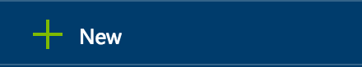

1. Within the **New** blade, click **Internet of Things**.

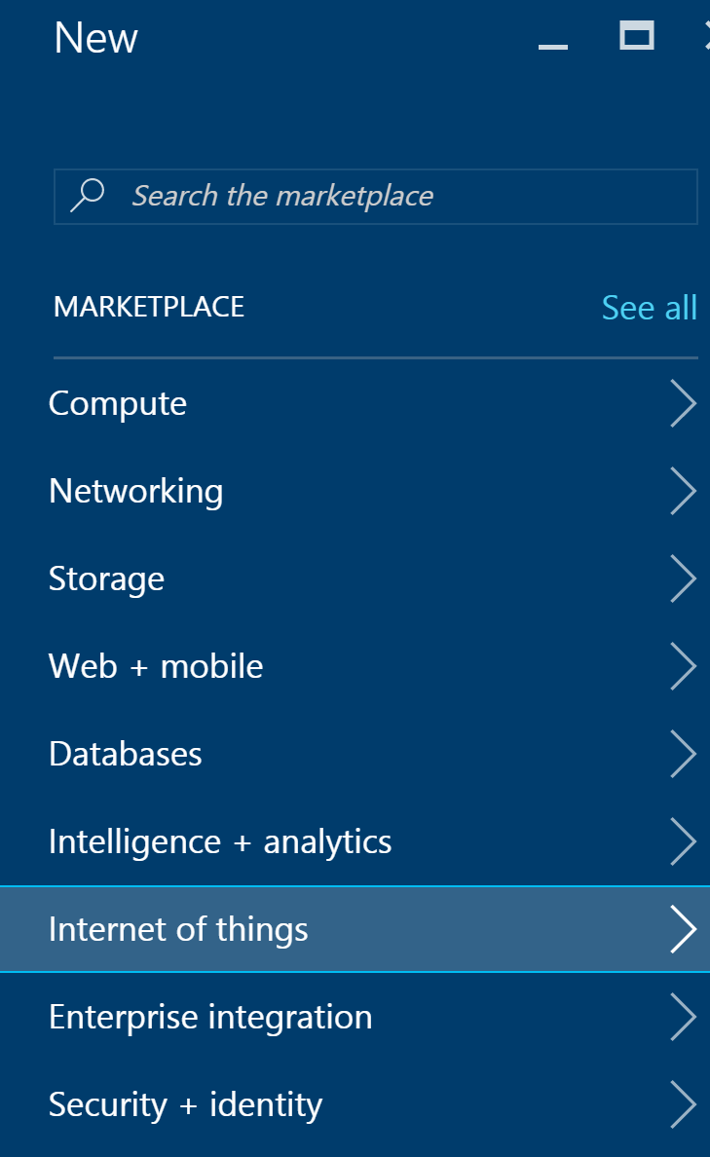

1. On the **Internet of Things** blade, click **IoT Hub**.

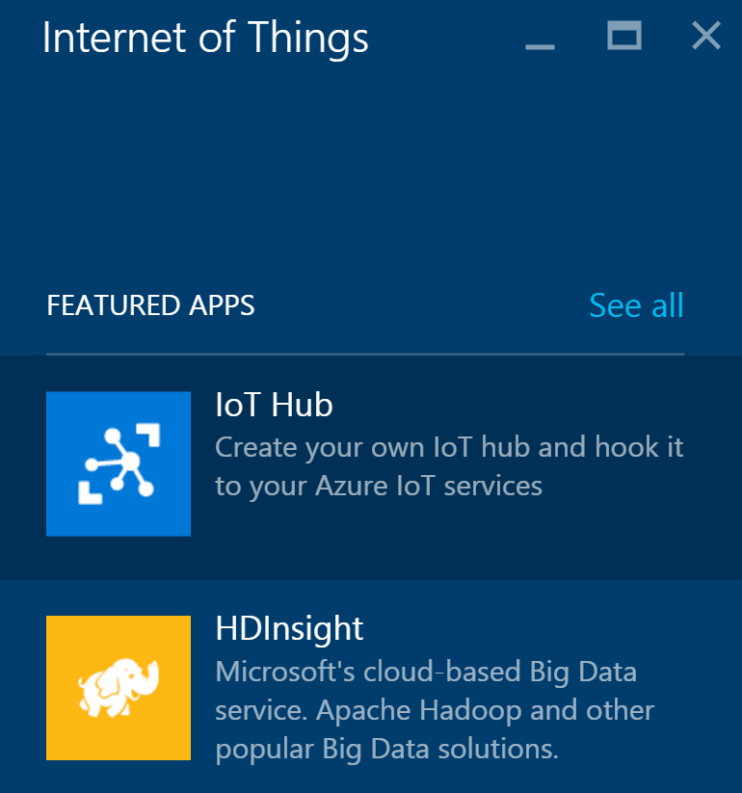

1. In the **IoT Hub** blade, provide a name for your new IoT Hub, choose a **Pricing and scale tier** (**S1** or **Free** is appropriate), set the **IoT Hub units** to **1**, choose the **Resource group** you created earlier, and choose the **Location**.

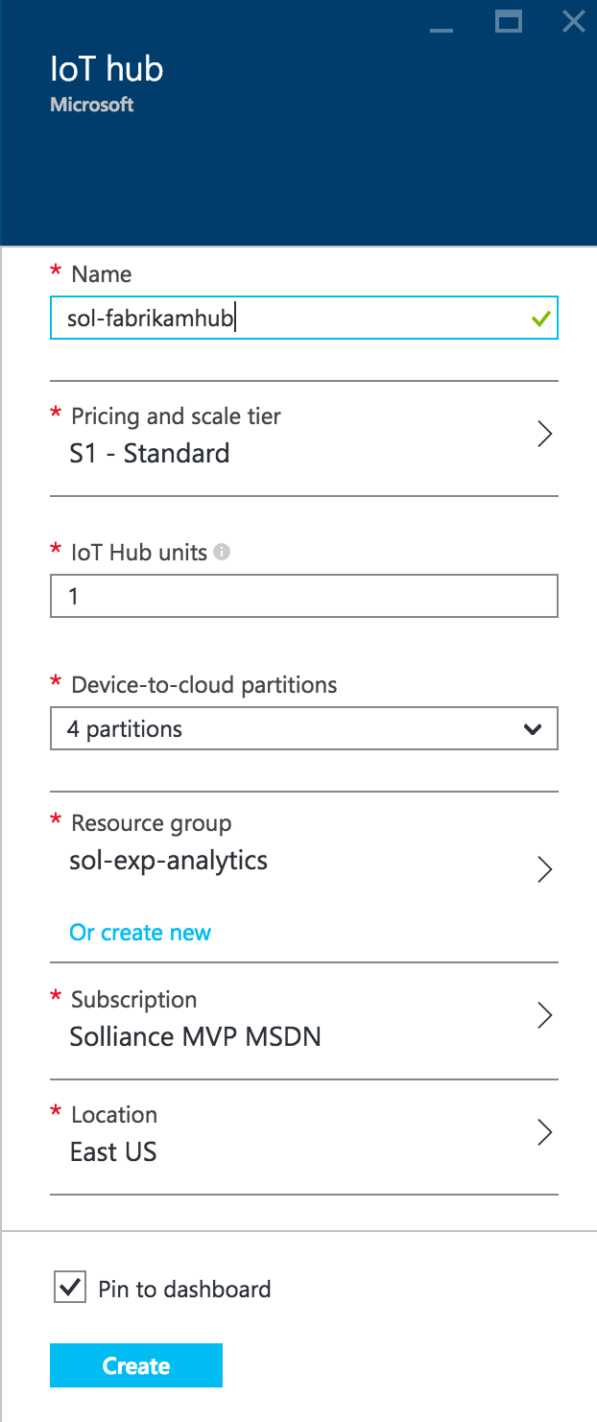

1. Click **Create**.
2. In the **Settings** blade that appears for your new IoT Hub, click **Shared access policies**.

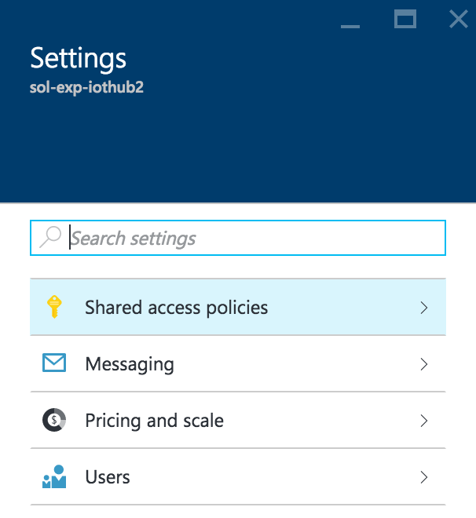

1. Click **iothubowner** policy.

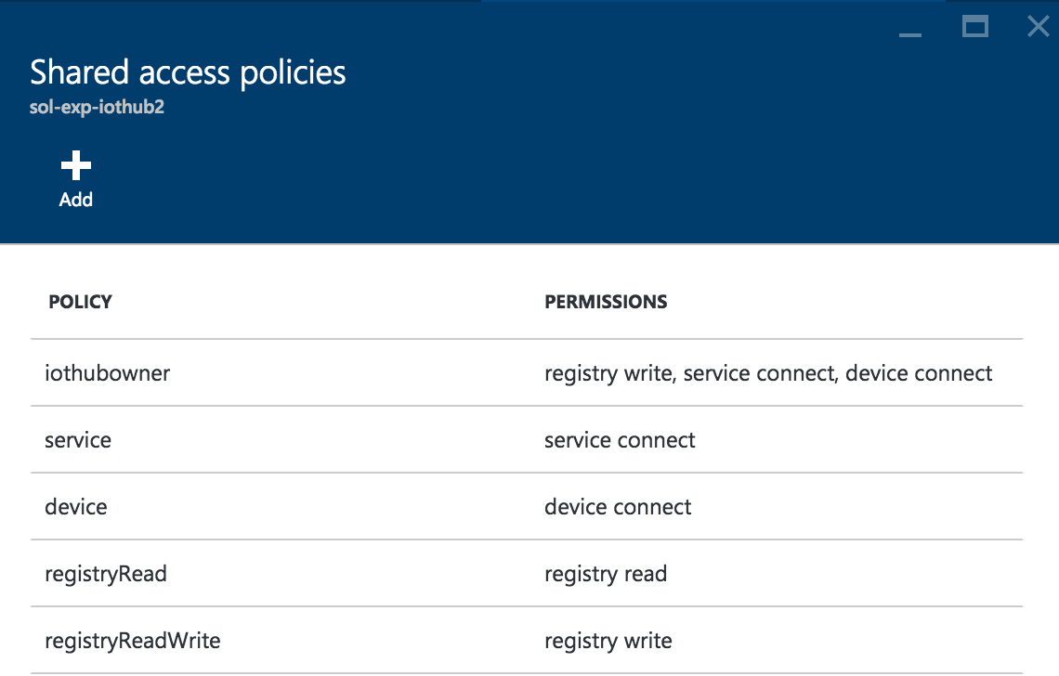

1. In the blade that appears, click the **Copy** button to the right of the Connection string—primary key located under the **Shared access keys** section.

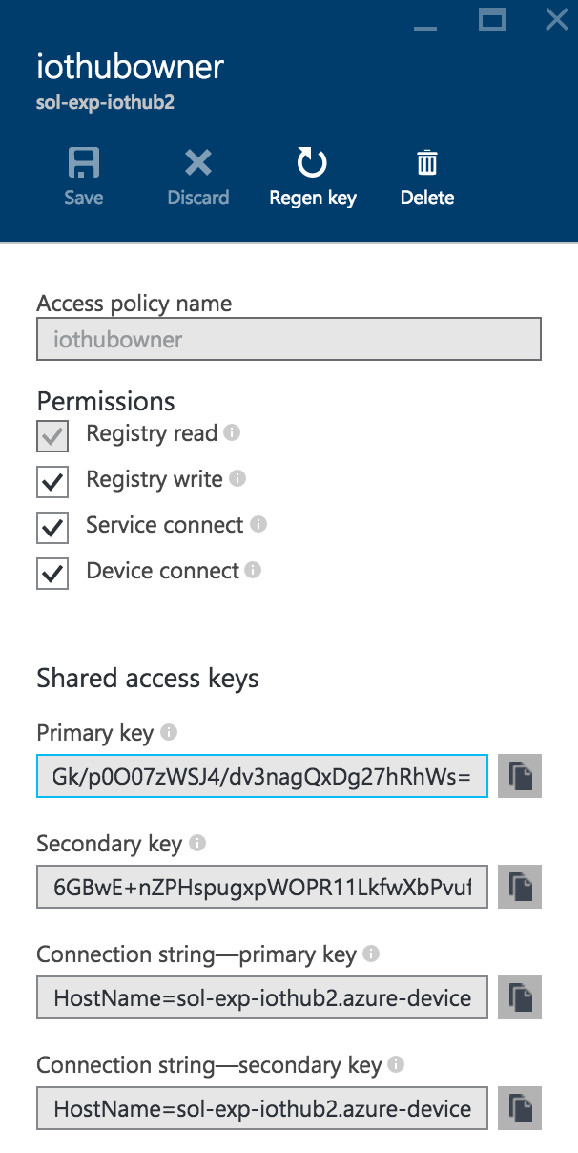

### Task 2: Configure the Smart Meter Simulator

If you want to save this connection string with your project (in case you stop debugging or otherwise close the simulator), you can set this as the default text for the text box. Follow these steps to configure the connection string:

1. Open the Smart Meter Simulator project in Visual Studio.
2. In **Solution Explorer**, double-click **MainForm.cs**.
3. In the **Windows Forms** designer surface, click the **text box** to select it.

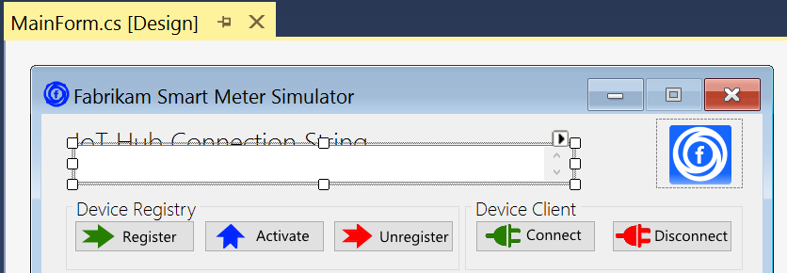

1. In the **Properties** panel, scroll until you are viewing the **Appearance** group and see the **Text** property. For the value of the **Text** property, paste your **IoT Hub connection string**.

Your connection string should now be present every time you run the Smart Meter Simulator.

### Task 3: Download and configure the Device Explorer

The Device Explorer is a sample project provided by Microsoft that enables you to see the list of devices provisioned within the IoT Hub registry.

1. Open your browser and navigate to:  
   <https://github.com/Azure/azure-iot-sdks>.
2. On the far right, click **Clone or download** and then **Download Zip**.

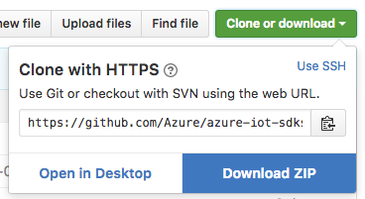

1. Extract the zip file, navigate to Tools\DeviceExplorer, and open **DeviceExplorer.sln**.
2. Build the **Solution**.
3. Press **Ctrl+F5** to run the solution without debugging (or click on Start Without Debugging from the Debug menu).
4. Device Explorer will appear as follows:

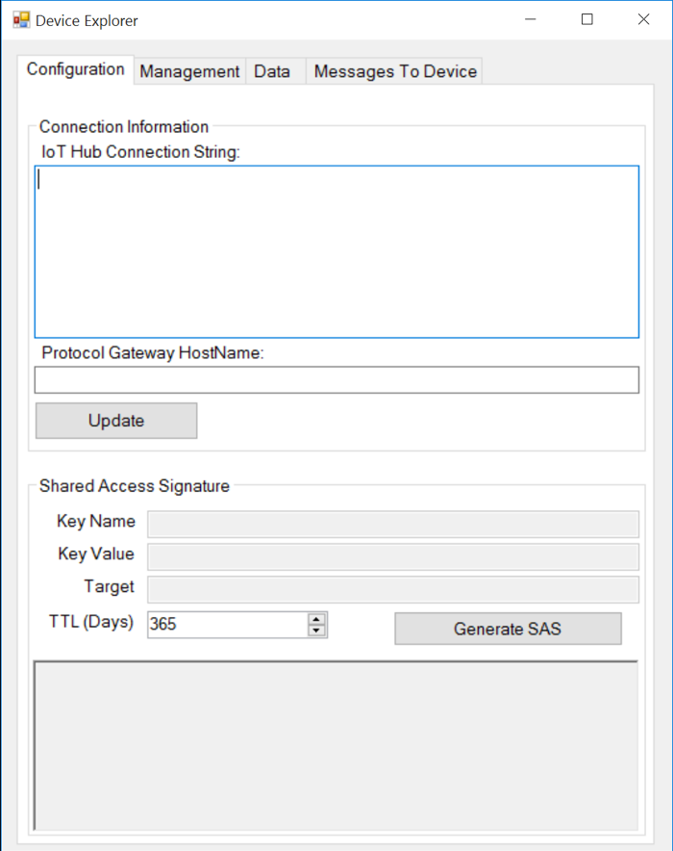

1. To get to the IoT Hub connection string to use, you could reuse the same connection string for the iothubowner policy you used for the Smart Meter Simulator; however, since we are only interested in querying the device registry, we can use the more specific registryRead.
2. From your **IoT Hub’s** blade, click **Settings**. In the **Settings** blade that appears, click **Shared access policies**.



1. Click the **registryRead** policy.



1. In the blade that appears, click the **Copy** button to the right of the Connection string—primary key located under the **Shared access keys** section.

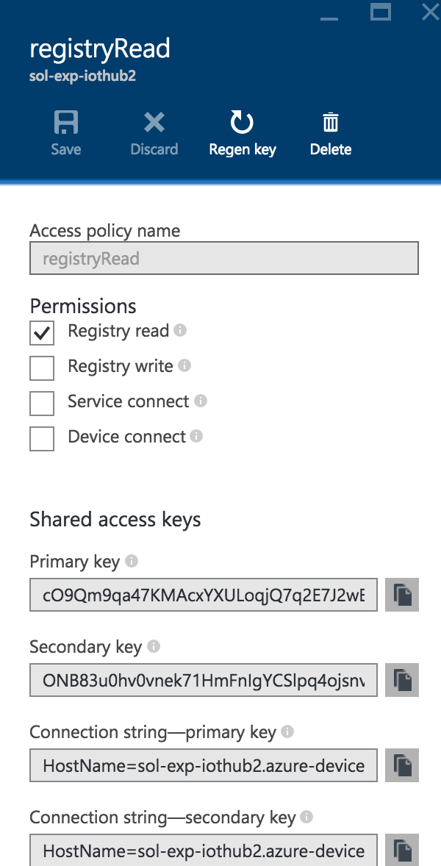

1. Return to **Device Explorer** and paste this value into the **IoT Hub Connection String**.
2. Click **Update**.

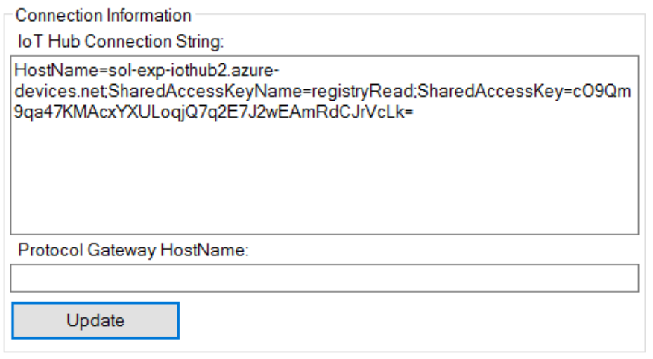

1. Click **OK** on the confirmation prompt.

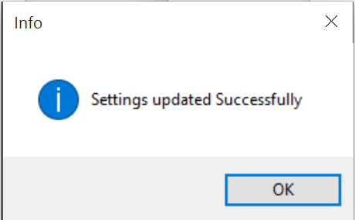

1. To confirm that you can query the registry, click the **Management** tab and then click **List**.

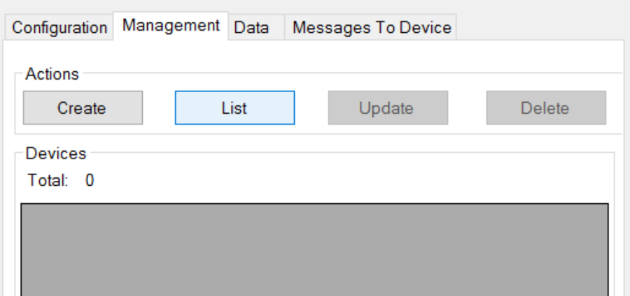

1. The grid under **Devices** should change to have headers as follows, and list any devices (which at this point should be 0).

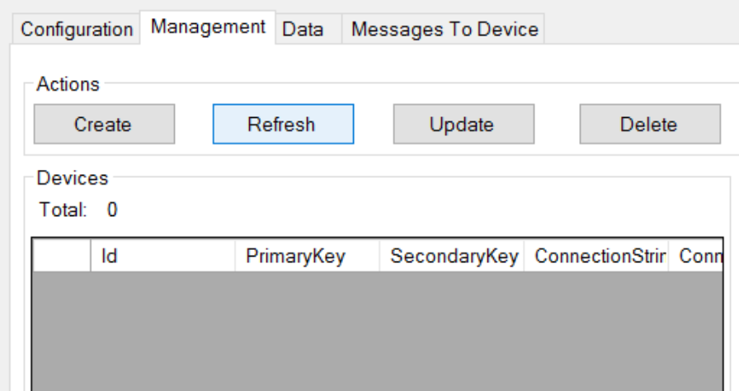

## Exercise 3: Completing the Smart Meter Simulator

Duration: 90 minutes

Synopsis: Fabrikam has left you a partially completed sample in the form of the Smart Meter Simulator solution. You will need to complete the missing lines of code that deal with device registration management and device telemetry transmission that communicate with your IoT Hub.

### Task 1: Implement device management with the IoT Hub

1. With the Smart Meter Simulator solution open in Visual Studio, use Solution Explorer to open the file **DeviceManager.cs**.
2. From the **View** menu, click **Task List**. There you will see a list of TODO tasks, where each task represents one line of code that needs to be completed. Copy the code in bold below the corresponding TODO item in the completed code that follows.
3. The following code represents the completed tasks in DeviceManager.cs:

class DeviceManager

{

static string connectionString;

static RegistryManager registryManager;

public static string HostName { get; set; }

public static void IotHubConnect(string cnString)

{

connectionString = cnString;

**//TODO: 1.Create an instance of RegistryManager from connectionString**

**registryManager = RegistryManager.CreateFromConnectionString(connectionString);**

var builder = IotHubConnectionStringBuilder.Create(cnString);

HostName = builder.HostName;

}

/// <summary>

/// Register a single device with the IoT hub. The device is initially registered in a

/// disabled state.

/// </summary>

/// <param name="connectionString"></param>

/// <param name="deviceId"></param>

/// <returns></returns>

public async static Task<string> RegisterDevicesAsync(string connectionString, string deviceId)

{

//Make sure we're connected

if (registryManager == null)

IotHubConnect(connectionString);

**//TODO: 2.Create new device**

**Device device = new Device(deviceId);**

**//TODO: 3.Initialize device with a status of Disabled**

**//Enabled in a subsequent step**

**device.Status = DeviceStatus.Disabled;**

try

{

**//TODO: 4.Register the new device**

**device = await registryManager.AddDeviceAsync(device);**

}

catch (Exception ex)

{

if (ex is DeviceAlreadyExistsException ||

ex.Message.Contains("DeviceAlreadyExists"))

{

**//TODO: 5.Device already exists, get the registered device**

**device = await registryManager.GetDeviceAsync(deviceId);**

**//TODO: 6.Ensure the device is disabled until Activated later**

**device.Status = DeviceStatus.Disabled;**

**//TODO: 7.Update IoT Hubs with the device status change**

**await registryManager.UpdateDeviceAsync(device);**

}

else

{

MessageBox.Show($"An error occurred while registering one or more devices:\r\n{ex.Message}");

}

}

//return the device key

return device.Authentication.SymmetricKey.PrimaryKey;

}

/// <summary>

/// Activate an already registered device by changing its status to Enabled.

/// </summary>

/// <param name="connectionString"></param>

/// <param name="deviceId"></param>

/// <param name="deviceKey"></param>

/// <returns></returns>

public async static Task<bool> ActivateDeviceAsync(string connectionString, string deviceId, string deviceKey)

{

//Server-side management function to enable the provisioned device

//to connect to IoT Hub after it has been installed locally.

//If device id device key are valid, Activate (enable) the device.

//Make sure we're connected

if (registryManager == null)

IotHubConnect(connectionString);

bool success = false;

Device device;

try

{

**//TODO: 8.Fetch the device**

**device = await registryManager.GetDeviceAsync(deviceId);**

**//TODO: 9.Verify the device keys match**

**if (deviceKey ==** **device.Authentication.SymmetricKey.PrimaryKey)**

{

**//TODO: 10.Enable the device**

**device.Status = DeviceStatus.Enabled;**

**//TODO: 11.Update IoT Hubs**

**await registryManager.UpdateDeviceAsync(device);**

success = true;

}

}

catch(Exception)

{

success = false;

}

return success;

}

/// <summary>

/// Deactivate a single device in the IoT Hub registry.

/// </summary>

/// <param name="connectionString"></param>

/// <param name="deviceId"></param>

/// <returns></returns>

public async static Task<bool> DeactivateDeviceAsync(string connectionString, string deviceId)

{

//Make sure we're connected

if (registryManager == null)

IotHubConnect(connectionString);

bool success = false;

Device device;

try

{

**//TODO: 12.Lookup the device from the registry by deviceId**

**device = await registryManager.GetDeviceAsync(deviceId);**

**//TODO: 13.Disable the device**

**device.Status = DeviceStatus.Disabled;**

**//TODO: 14.Update the registry**

**await registryManager.UpdateDeviceAsync(device);**

success = true;

}

catch (Exception)

{

success = false;

}

return success;

}

/// <summary>

/// Unregister a single device from the IoT Hub Registry

/// </summary>

/// <param name="connectionString"></param>

/// <param name="deviceId"></param>

/// <returns></returns>

public async static Task UnregisterDevicesAsync(string connectionString, string deviceId)

{

//Make sure we're connected

if (registryManager == null)

IotHubConnect(connectionString);

**//TODO: 15.Remove the device from the Registry**

**await registryManager.RemoveDeviceAsync(deviceId);**

}

/// <summary>

/// Unregister all the devices managed by the Smart Meter Simulator

/// </summary>

/// <param name="connectionString"></param>

/// <returns></returns>

public async static Task UnregisterAllDevicesAsync(string connectionString)

{

//Make sure we're connected

if (registryManager == null)

IotHubConnect(connectionString);

for(int i = 0; i <= 9; i++)

{

string deviceId = "Device" + i.ToString();

**//TODO: 16.Remove the device from the Registry**

**await registryManager.RemoveDeviceAsync(deviceId);**

}

}

}

### Task 2: Implement the communication of telemetry with the IoT Hub

1. Open **Sensor.cs** and complete the TODO items indicated within the code that are responsible for transmitting telemetry data to the IoT Hub.
2. The following code shows the completed result:

class Sensor

{

private DeviceClient _DeviceClient;

private string _IotHubUri { get; set; }

public string DeviceId { get; set; }

public string DeviceKey { get; set; }

public DeviceState State { get; set; }

public string StatusWindow { get; set; }

public double CurrentTemperature

{

get

{

double avgTemperature = 70;

Random rand = new Random();

double currentTemperature = avgTemperature + rand.Next(-6, 6);

if(currentTemperature <= 68)

TemperatureIndicator = SensorState.Cold;

else if(currentTemperature > 68 && currentTemperature < 72)

TemperatureIndicator = SensorState.Normal;

else if(currentTemperature >= 72)

TemperatureIndicator = SensorState.Hot;

return currentTemperature;

}

}

public SensorState TemperatureIndicator { get; set; }

public Sensor(string iotHubUri, string deviceId, string deviceKey)

{

_IotHubUri = iotHubUri;

DeviceId = deviceId;

DeviceKey = deviceKey;

State = DeviceState.Registered;

}

public void InstallDevice(string statusWindow)

{

StatusWindow = statusWindow;

State = DeviceState.Installed;

}

/// <summary>

/// Connect a device to the IoT Hub by instantiating a DeviceClient for that Device by Id and Key.

/// </summary>

public void ConnectDevice()

{

**//TODO: 17. Connect the Device to Iot Hub by creating an instance of DeviceClient**

**_DeviceClient = DeviceClient.Create(_IotHubUri, new DeviceAuthenticationWithRegistrySymmetricKey(DeviceId, DeviceKey));**

//Set the Device State to Ready

State = DeviceState.Ready;

}

public void DisconnectDevice()

{

//Delete the local device client

_DeviceClient = null;

//Set the Device State to Activate

State = DeviceState.Activated;

}

/// <summary>

/// Send a message to the IoT Hub from the Smart Meter device

/// </summary>

public async void SendMessageAsync()

{

var telemetryDataPoint = new

{

id = DeviceId,

time = DateTime.UtcNow.ToString("o"),

temp = CurrentTemperature

};

**//TODO: 18.Serialize the telemetryDataPoint to JSON**

**var messageString = JsonConvert.SerializeObject(telemetryDataPoint);**

**//TODO: 19.Encode the JSON string to ASCII as bytes and create new Message with the bytes**

**var message = new Message(Encoding.ASCII.GetBytes(messageString));**

**//TODO: 20.Send the message to the IoT Hub**

**var sendEventAsync = _DeviceClient?.SendEventAsync(message);**

**if (sendEventAsync != null) await sendEventAsync;**

}

}

### Task 3: Verify device registration and telemetry

1. Return to your running instance of **Device Explorer**, click the **Management** tab, and then click **Refresh**. Confirm that you have 0 devices listed.



1. Next, run the **Smart Meter Simulator**.

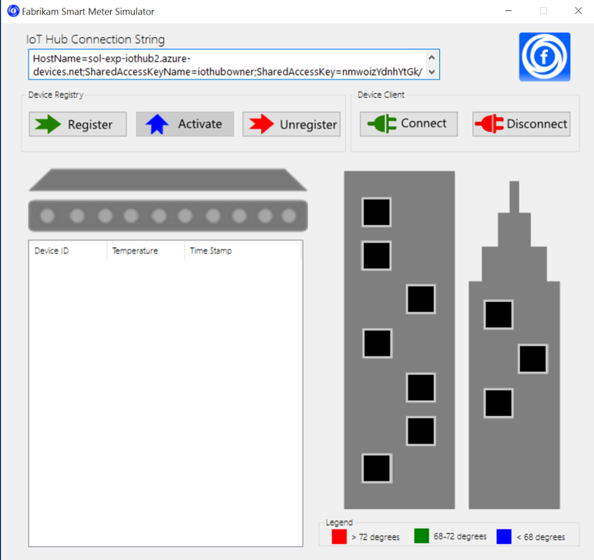

1. Click **Register**. The windows within the building should turn from black to gray.

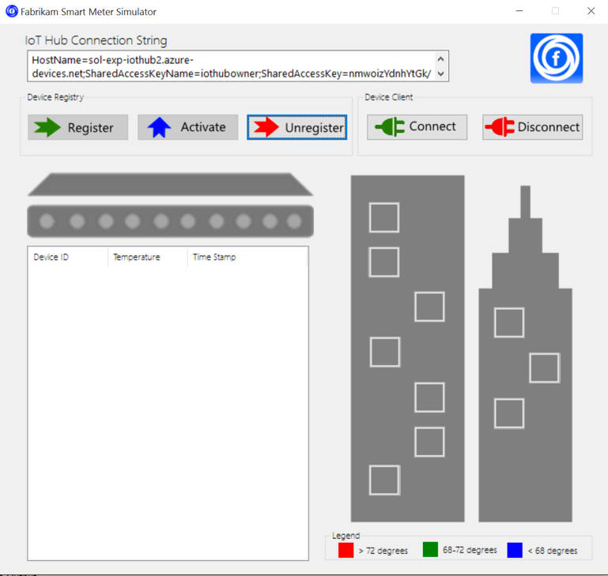

1. Click the windows. Each represents a device for which you want to simulate device installation. The selected windows should turn yellow.

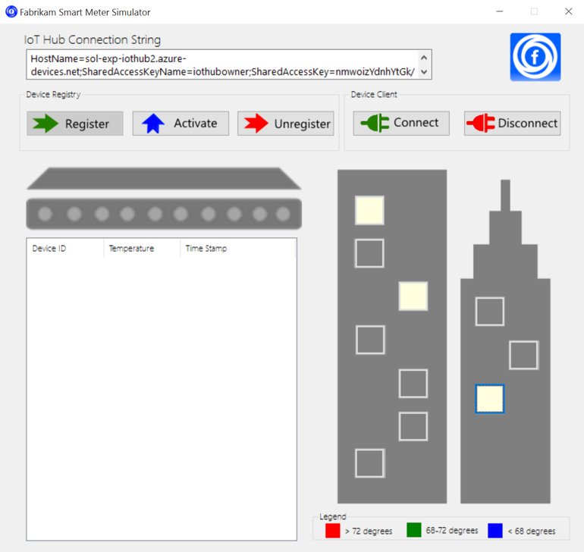

1. Click **Activate** to simulate changing the device status from disabled to enabled in the Iot Hub Registry. The selected windows should turn green.

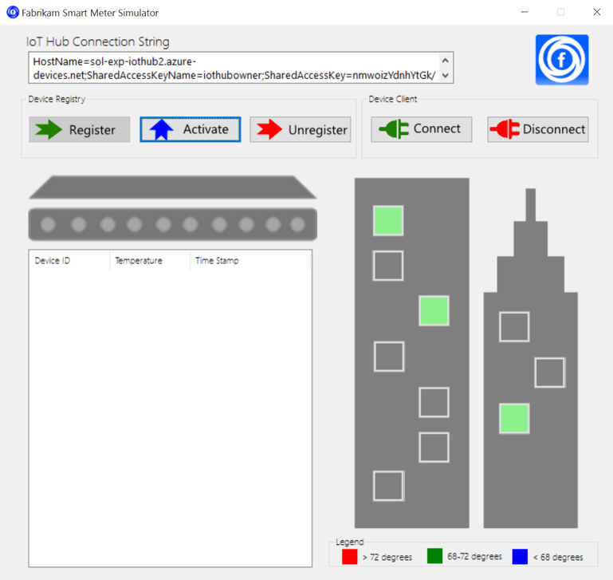

1. At this point, you have registered 10 devices (the gray windows) but activated only the ones you selected (in green). To view this list of devices, switch over to **Device Explorer**.
2. On the **Management** tab, click **Refresh**.
3. This time you should see all 10 devices listed.

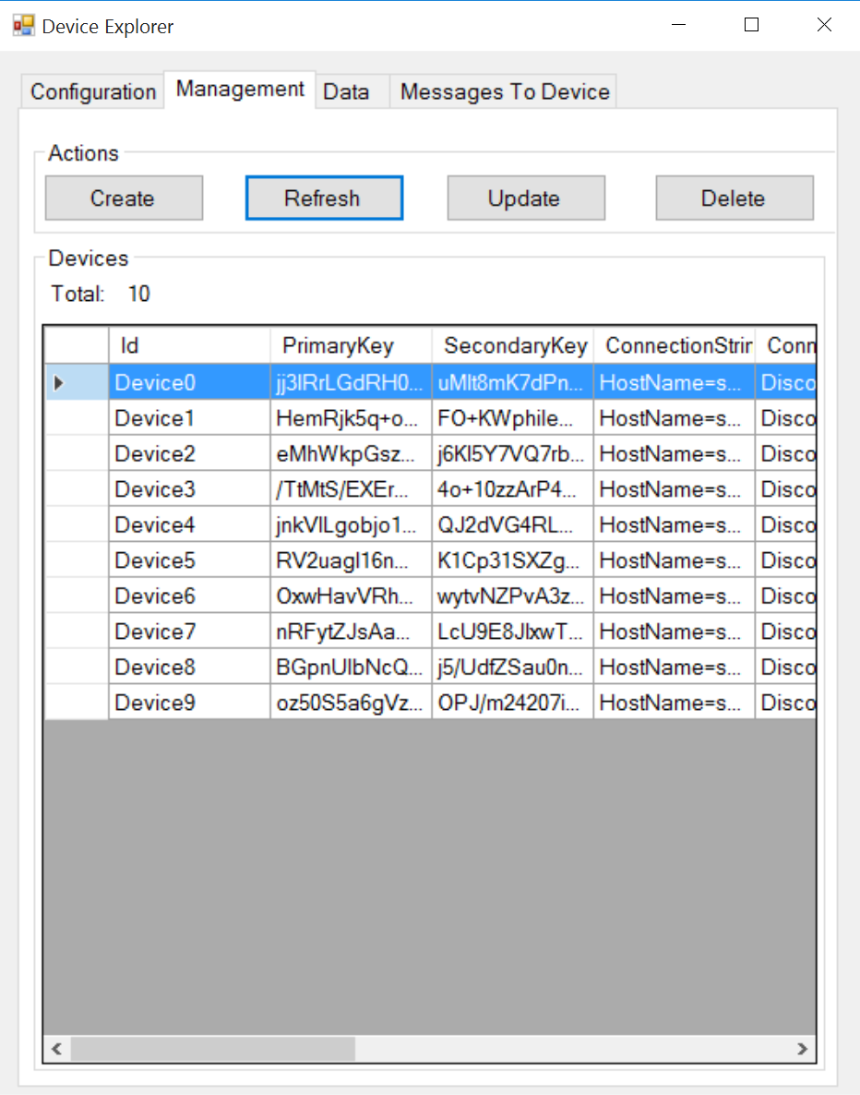

1. If you scroll the **Devices grid** to the right, you should see a **State** column. The devices that you activated will have a **State** value of **Enabled**. Those that you did not, will have a **State** value of **Disabled**.

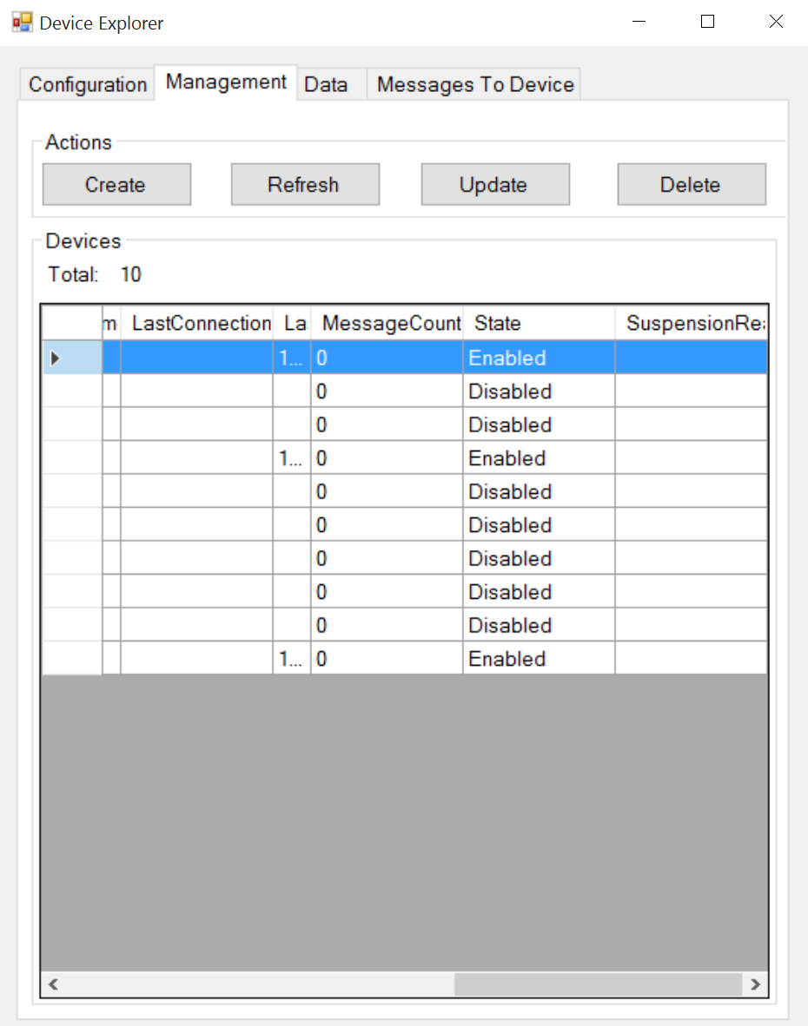

1. Return to the **Smart Meter Simulator**.
2. Click **Connect**. Within a few moments, you should begin to see activity as the windows change color indicating the smart meters are transmitting telemetry. The grid on the left will list each telemetry message transmitted and the simulated temperature value.

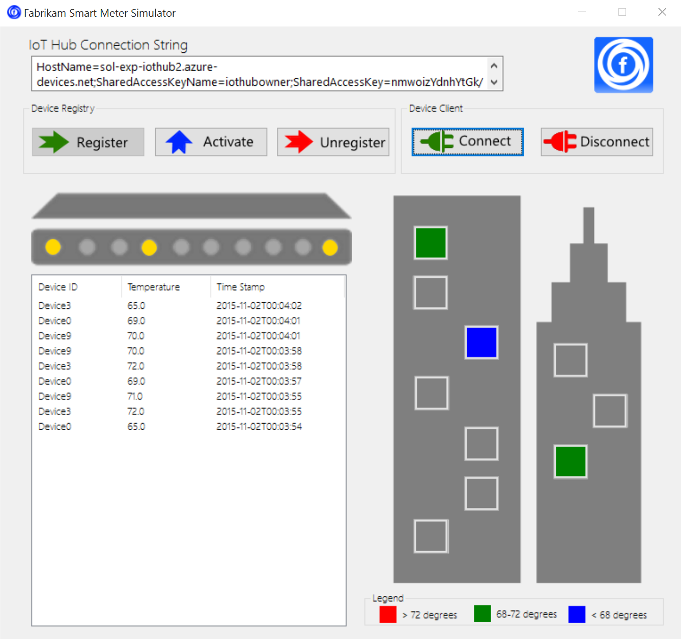

1. Allow the smart meter to continue to run. (Whenever you want to stop the transmission of telemetry, click the **Disconnect** button.)

## Exercise 4: Hot path data processing with Stream Analytics

Duration: 45 minutes

Synopsis: Fabrikam would like to visualize the “hot” data showing the average temperature reported by each device over a 5-minute window in Power BI.

### Task 1: Create a Stream Analytics job for hot path processing to Power BI

1. In your browser, navigate to the **Azure Portal** (<https://portal.azure.com>).
2. Click **+New** in the navigation bar at the left.  
   
3. Click **Internet of things**, then **Stream Analytics job**.  
   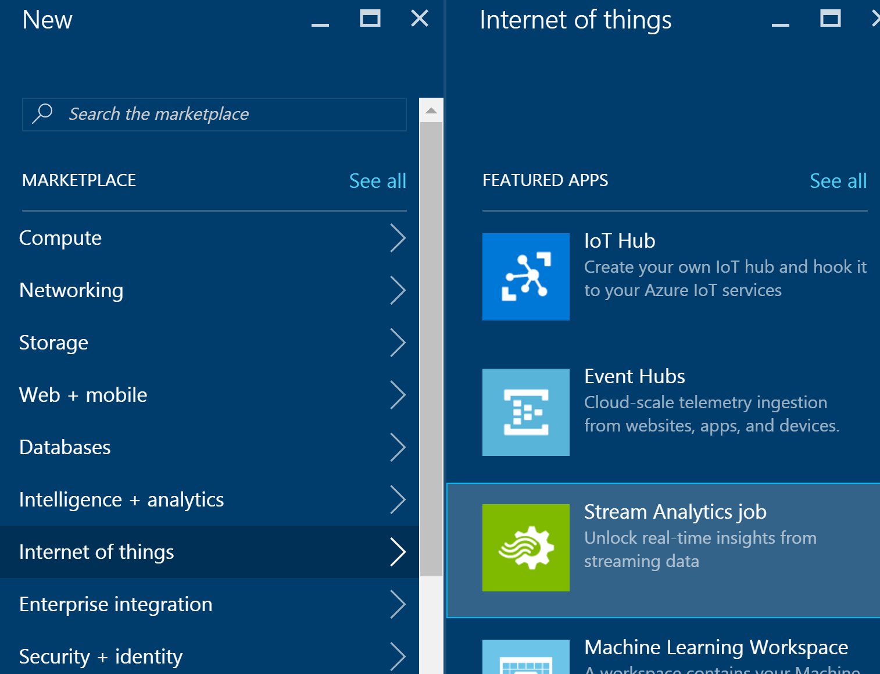
4. Provide the following:
   1. Job Name: <name>
   2. Subscription: <your subscription>
   3. Resource Group: <same group as other resources>
   4. Location: <same region as other resources>

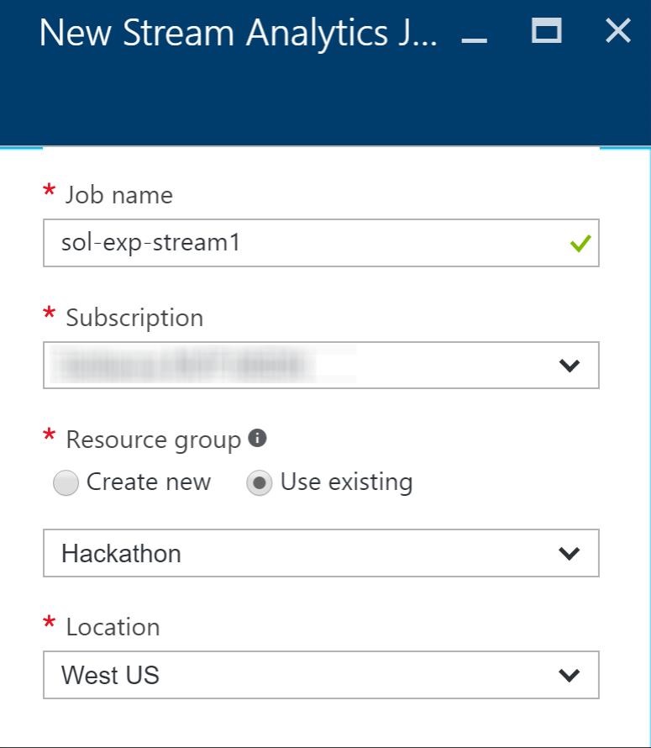

1. Click **Create**.

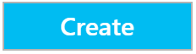

1. Once provisioned, go to **Inputs** for your Stream Analytics job and add an input connected to your IoT Hub.
   1. Click on **Inputs** under JOB TOPOLOGY, or click the Inputs box on the Overview blade.  
      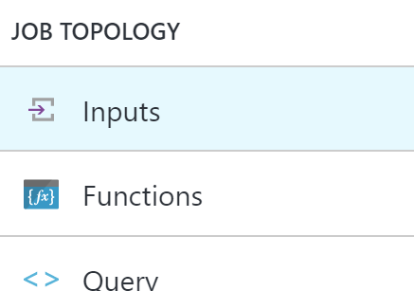
   2. On the **Inputs** blade, click **Add** in the **command bar** at the top.



* 1. Configure the **IoT Hub settings** as follows:
     1. Input Alias: temps.
     2. Source Type: Data stream
     3. Subscription: Use IoT hub from current subscription
     4. IoT Hub: Select your existing IoT Hub
     5. Endpoint: Messaging
     6. Shared Access Policy Name: Set to Service
     7. Consumer Group: Leave as $Default
     8. Event serialization format: JSON
     9. Encoding: UTF-8  
        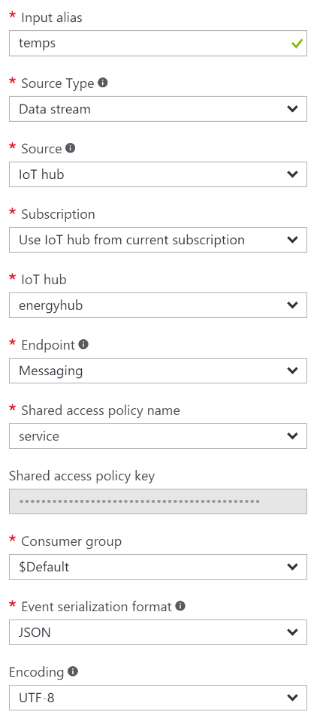
  2. Click **create**.

1. Go to the **Outputs** blade and add the output destination for the query.
   1. Click on **Outputs** under JOB TOPOLOGY.  
      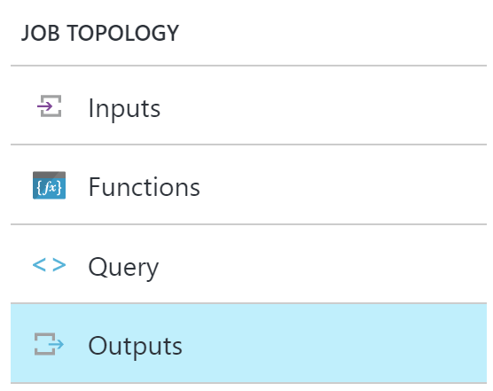
   2. On the **Outputs** blade, click **Add** in the **command bar** at the top.



* 1. Set the **Output alias** to **powerbi**.
  2. Select **Power BI** under **Sink**.
  3. Click on **Authorize** underneath Authorize Connection.

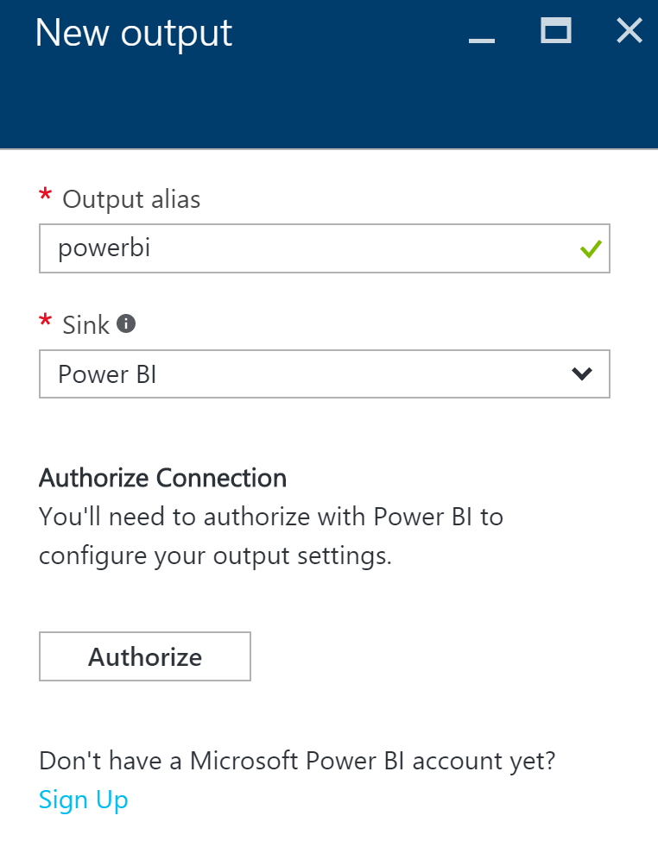

* 1. Follow the on screen prompts to log on to your Power BI account. Make sure you select **Work or school account**, since Power BI only supports organizational accounts at this time.

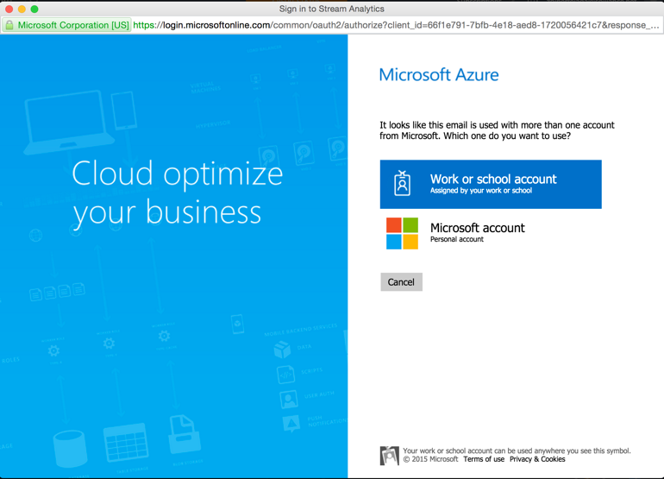

* 1. After authenticating, you will be taken back to the **New output** form, which will display Group Workspace: leave at My Workspace three new fields to fill out:
     1. Dataset Name: avgtemps
     2. Table Name: avgtemps
     3. Click on **Create**.  
        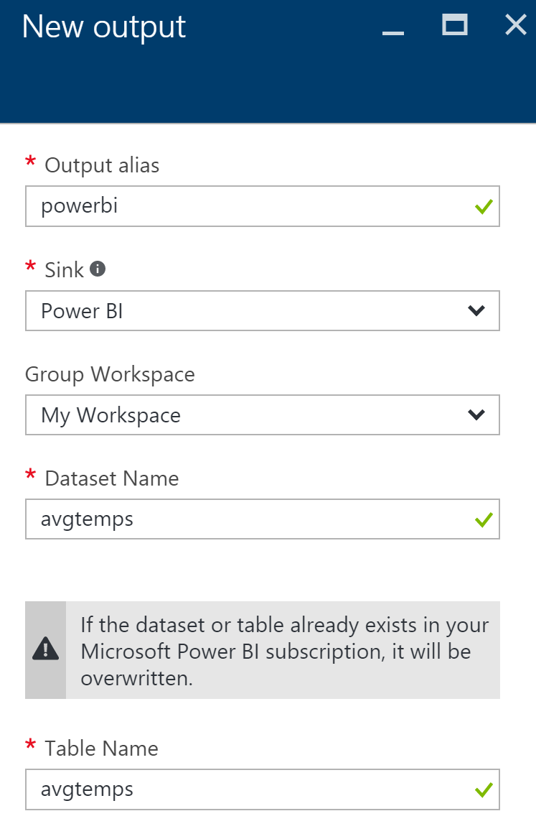

1. Go to the **Query** blade by clicking on Query under JOB TOPOLOGY.  
   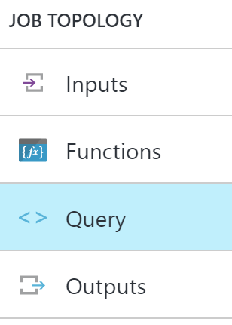
2. Paste the following query, and click **Save** in the **command bar** at the top. (Be sure to substitute in your output alias and input alias):

SELECT AVG(temp) AS Average, id

INTO powerbi

FROM temps

GROUP BY TumblingWindow(minute, 5), id

1. Go to the **Overview** blade on your **Stream Analytics job**, click **Start** in the **command bar** to begin the job.
   1. Leave the **Job output start time** setting at **Now** and click **Start**.

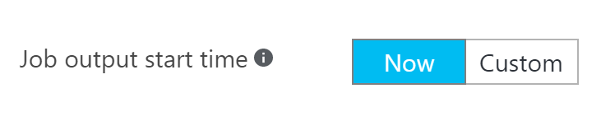

1. Verify that you are showing a non-zero amount of **Input Events** on the **Monitoring** chart on the overview page. You may need to reconnect your devices on the Smart Meter Simulator and let it run for a while to see the events.

### Task 2: Visualize hot data with Power BI

1. Log on to **Power BI** to see if data is being collected.
2. A new dataset should appear. (It is starred to indicate it is new)

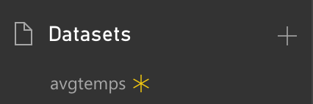

1. Click the new dataset to go the **report designer**.
2. Add a **Column Chart visualization**.

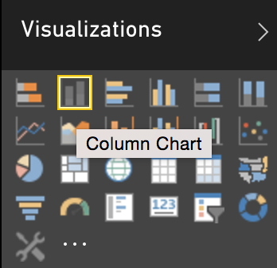

1. Set the **axis** to **id** and the value to Max of average. To do this, drag the **id** field to Axis, then the **average** field to Value. Click the down arrow next to **average**, and select **Maximum**.

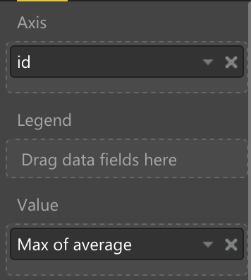

1. Repeat steps 4 and 5, this time adding a **Column Chart** for **Min of average**.

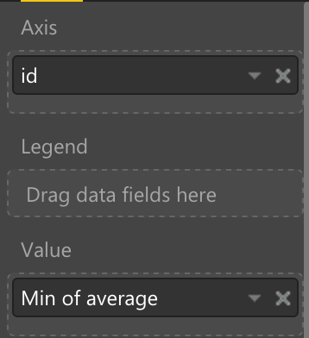

1. Add a **table visualization**.

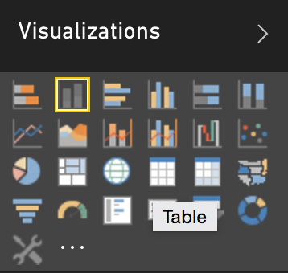

1. Set the values to **id** and **Average of average**.

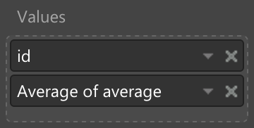

1. Save the report.

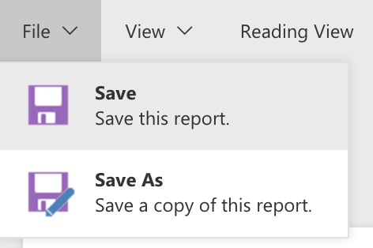

1. Switch to **Reading View**.

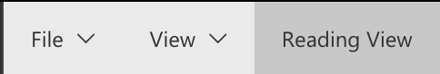

1. Within the report, click one of the columns to see the data for just that device.

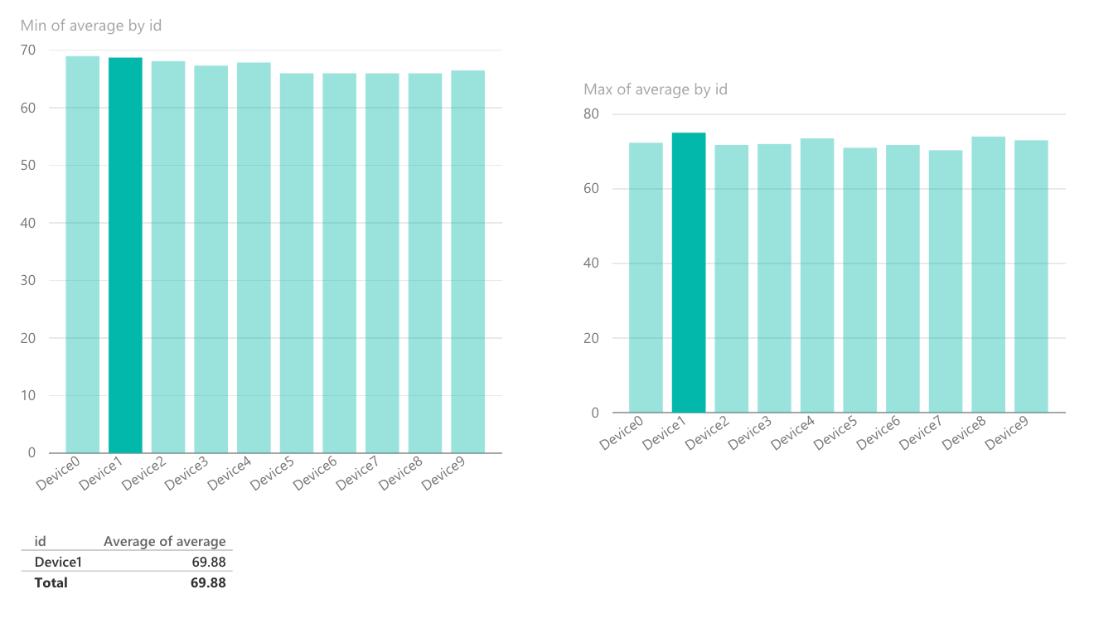

## Exercise 5: Cold path data processing with HDInsight Spark

Duration: 60 minutes

Synopsis: Fabrikam would like to be able to capture all of the “cold” data into scalable storage so that they can summarize it periodically using a Spark SQL query.

### Task 1: Create the Stream Analytics job for cold path processing

In order to capture all metrics for the cold path, set up another Stream Analytics job that will write all events to Blob storage for analyses by Spark running on HDInsight.

1. In your browser, navigate to the **Azure Portal** (<https://portal.azure.com>).
2. Click **+New** in the navigation bar at the left.  
   
3. Click **Internet of things**, then **Stream Analytics job**.  
   
4. Provide the following:
   1. Job Name: <name>
   2. Subscription: <your subscription>
   3. Resource Group: <same group as other resources>
   4. Location: <same region as other resources>

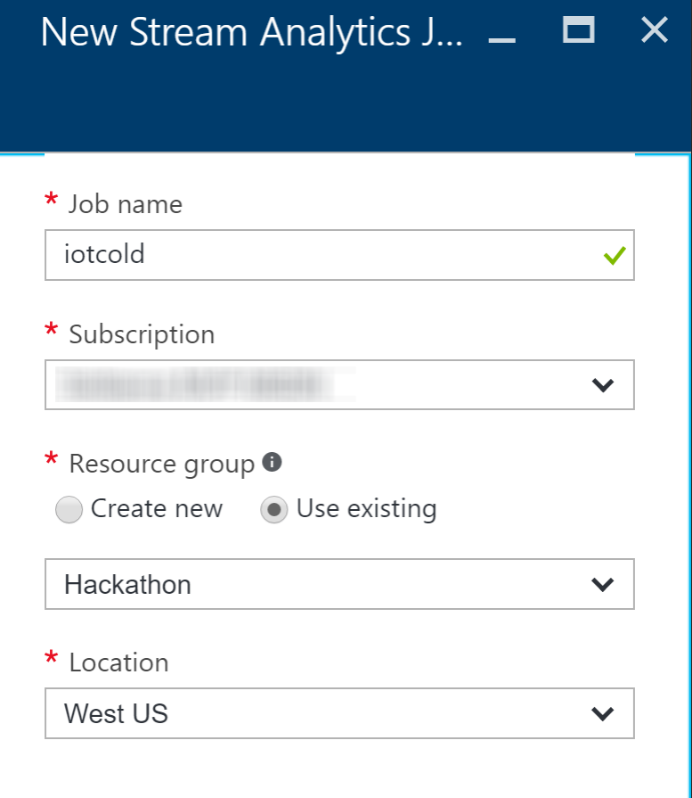

1. Click **Create**.



1. Once provisioned, go to **Inputs** for your Stream Analytics job and add an input connected to your IoT Hub.
   1. Click on **Inputs** under JOB TOPOLOGY, or click the Inputs box on the Overview blade.  
      
   2. On the **Inputs** blade, click **Add** in the **command bar** at the top.



* 1. Configure the **IoT Hub settings** as follows:
     1. Input Alias: iothub
     2. Source Type: Data stream
     3. Subscription: Use IoT hub from current subscription
     4. IoT Hub: Select your existing IoT Hub
     5. Endpoint: Messaging
     6. Shared Access Policy Name: Set to Service
     7. Consumer Group: Leave as $Default
     8. Event serialization format: JSON
     9. Encoding: UTF-8  
        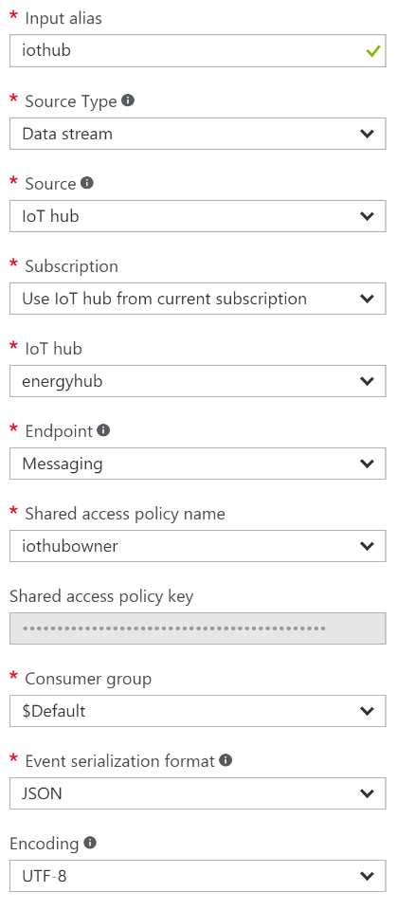
  2. Click **create**.

1. Go to the **Outputs** blade and add the output destination for the query.
   1. Click on **Outputs** under JOB TOPOLOGY.  
      
   2. On the **Outputs** blade, click **Add** in the **command bar** at the top.



* 1. On the **New output** blade, provide the following:
     1. Output Alias: blobs
     2. Sink: Blob storage
     3. Subscription: <choose Use Storage Account from Current Subscription>
     4. Storage Account: <enter the storage account name you used for HDInsight>
     5. Container: <select the existing container, which should be the same one as used for your HDInsight cluster>
     6. Path Prefix Pattern: smartmeters/{date}/{time}
     7. Date Format: YYYY/MM/DD
     8. Time Format: HH
     9. Event Serialization Format: <select CSV>
     10. Delimiter: <select comma (,)>
     11. Encoding: <select UTF-8>
  2. Click **Create**.

1. Go to the **Query** blade by clicking on Query under JOB TOPOLOGY.  
   
2. Paste the following query, and click **Save** in the **command bar** at the top. (Be sure to substitute in your output alias and input alias):  
     
   SELECT

*

INTO

blobs

FROM  
 iothub

1. Go to the **Overview** blade on your **Stream Analytics job**, click **Start** in the **command bar** to begin the job.
   1. Leave the **Job output start time** setting at **Now** and click **Start**.



1. Verify that you are showing a non-zero amount of **Input Events** on the **Monitoring** chart on the overview page.

### Task 2: Verify CSV files in Blob storage

1. Open **Visual Studio**. From the **View** menu, select **Server Explorer**.

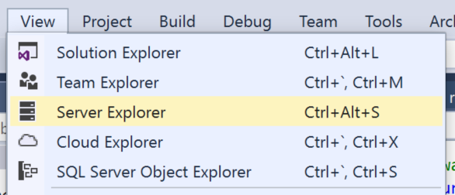

1. In **Server Explorer**, click **Connect to Microsoft Azure Subscription**.

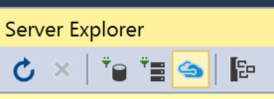

1. When prompted to sign in to Visual Studio, enter your **login** and click **Continue**.

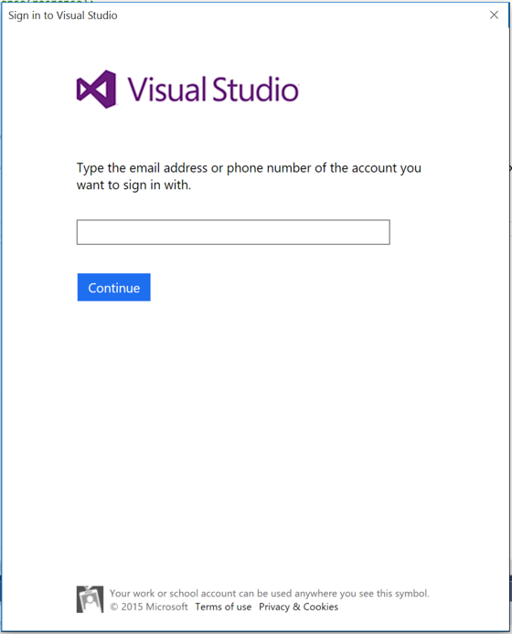

1. Choose the appropriate option for your work or school account or Microsoft account.

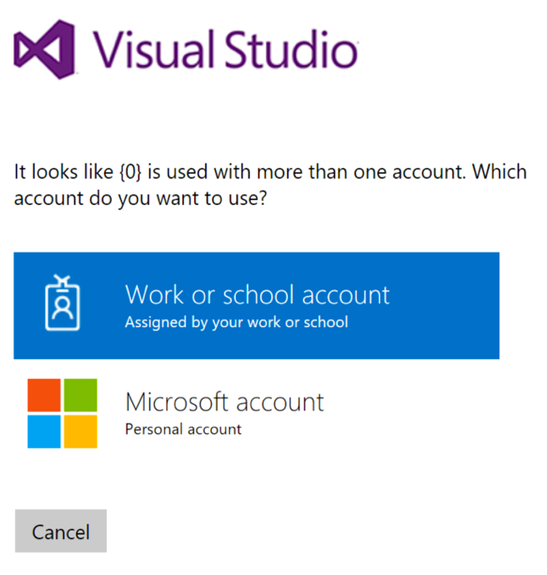

1. Complete your sign in by entering your **password** and clicking **Sign in**.

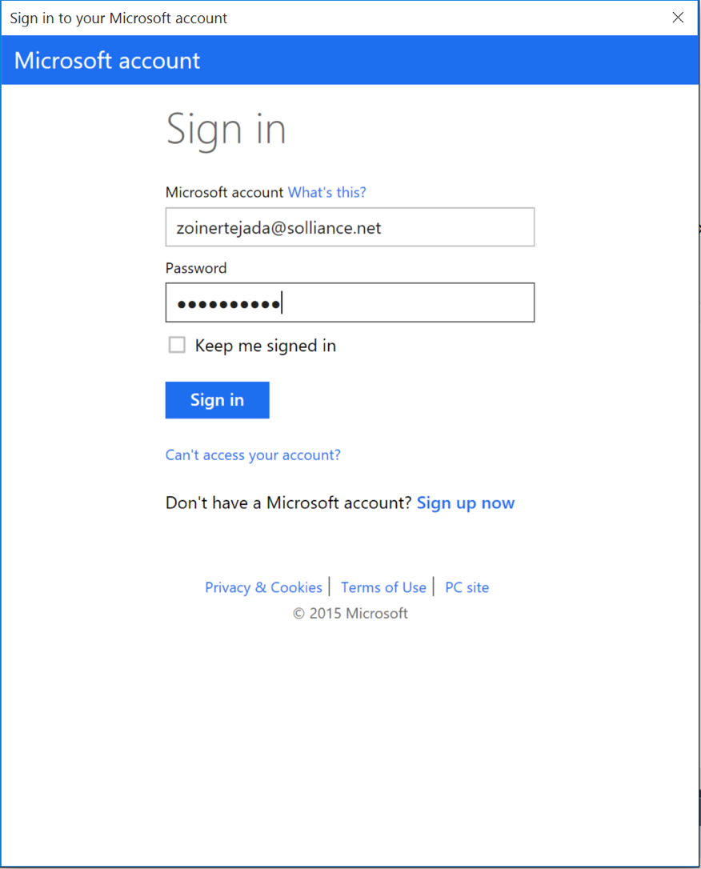

1. Allow Server Explorer about 30 seconds to load your subscription resources.
2. Expand **Azure** and then expand **HDInsight**. It may take a few moments to load your storage accounts.

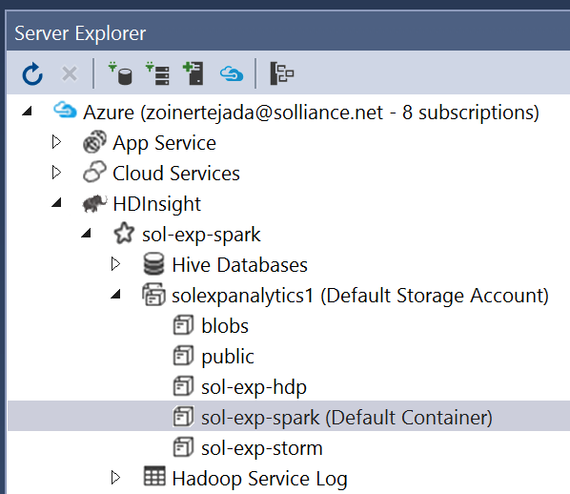

1. Expand the **Default Storage Account** used for your HDInsight cluster, and right-click the container named after your HDInsight cluster. Select **View Container**.

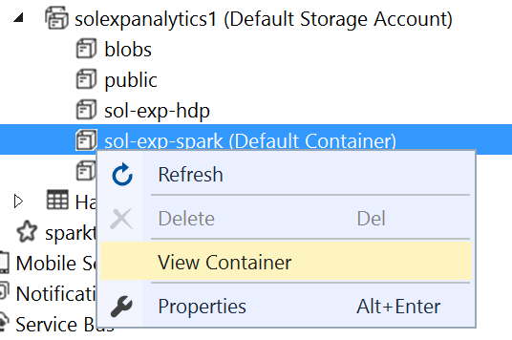

1. Verify files are being written to Blob storage and take note of the path to one of the files (the files should be located underneath the smartmeters folder).

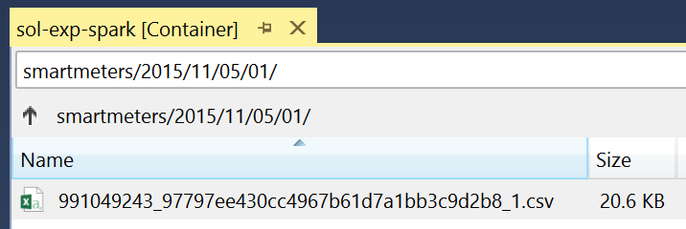

### Task 3: Process with Spark SQL

1. Navigate to the blade for your Spark Cluster in the Portal.
2. Under Quick Links, click **Cluster Dashboards**.

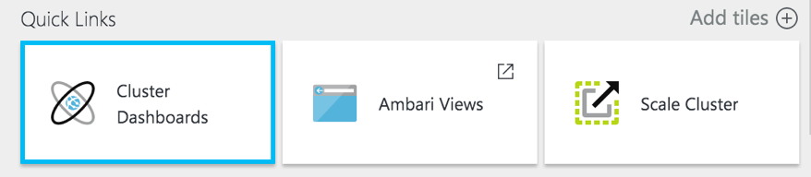

1. On the Cluster Dashboards blade, select **Jupyter Notebook**. If prompted, login with admin credentials your provided.  
   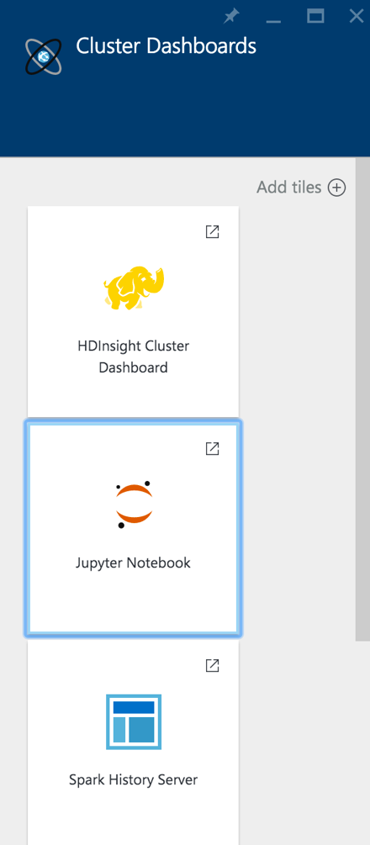
2. From the navigation bar in the Jupyter site, select **New** and then **Spark.**   
   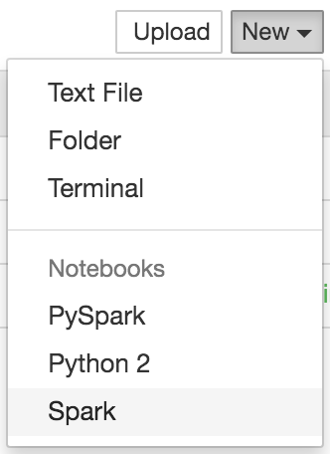
3. In the first text area (referred to as a paragraph in notebook jargon), enter the following **Scala code** that will load, parse, and save your batch scored flight data as a table that you can later query using Spark SQL. Modify the second line with the corrected path to your telemetry file.

var hiveContext = sqlContext

val rawText = hiveContext.read.text("wasb:///smartmeters/**2015/10/23/01/991049243_a399a1767ced448c9f6482285f35ab1b_1.csv**")

case class SmartMeterMetrics(id:String,time:String,temp:Integer)

val telemetryRDD = rawText.map(row => row.getString(0).split(",")).filter(s=>s(0) != "id").map(

s => SmartMeterMetrics(s(0), s(1), s(2).toInt)

)

val telemetryDF = hiveContext.createDataFrame(telemetryRDD)

telemetryDF.write.saveAsTable("SmartMeters")

1. Next, click the **Run** icon in the toolbar to execute this code and create the **SmartMeters** table.   
   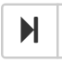
2. The block is finished running when the In[*] changes to In[1]  
   ../../../../../../Captures/Screen%20Shot%202016-04-04%20at%208.09.49%20PM.png
3. In the second cell, enter the following SQL query and run it.

%%sql

select id, count(*) as count, avg(temp) averageTemp from SmartMeters group by id order by id

1. Next, create a table that will summarize the telemetry collected using the previous query. In a new paragraph, try running the following query:

//query the table to create a summary result set

val summary = hiveContext.sql("select id, count(*) as count, avg(temp) averageTemp from SmartMeters group by id order by id")

//save the new pre-computed view

summary.write.saveAsTable("DeviceSummary")

1. Next, query from this summary table by executing the following query.

%%sql

select * from DeviceSummary

1. In the results, click the **Bar** button.
2. In the X dropdown, select id.
3. In the Y dropdown, select averageTemp.
4. In the Func dropdown, select Avg.
5. Check the box for Log scale Y.
6. Observe the results graphed as a column chart, where each column represents a device’s average temperature.

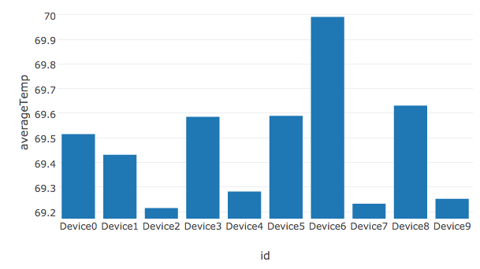

## Exercise 6: Reporting device outages with IoT Hub Operations Monitoring

Duration: 20 minutes

Synopsis: Fabrikam would like to be alerted when devices disconnect, but fail to reconnect after a period. Since they are already using PowerBI to visualize hot data, they would like to see a list of any of these devices in a report.

### Task 1: Enable verbose connection monitoring on the IoT Hub

To keep track of device connects and disconnects, we first need to enable verbose connection monitoring.

1. In your browser, navigate to the **Azure Portal** (<https://portal.azure.com)>.
2. Open the IoT Hub you provisioned earlier.
3. Under GENERAL in the left-hand menu, click on **Operations monitoring**.  
   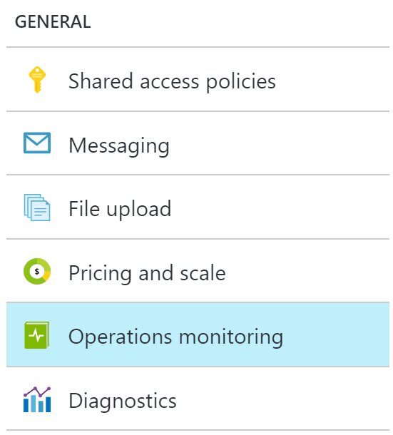
4. Click on **Verbose** under **Connections**.  
   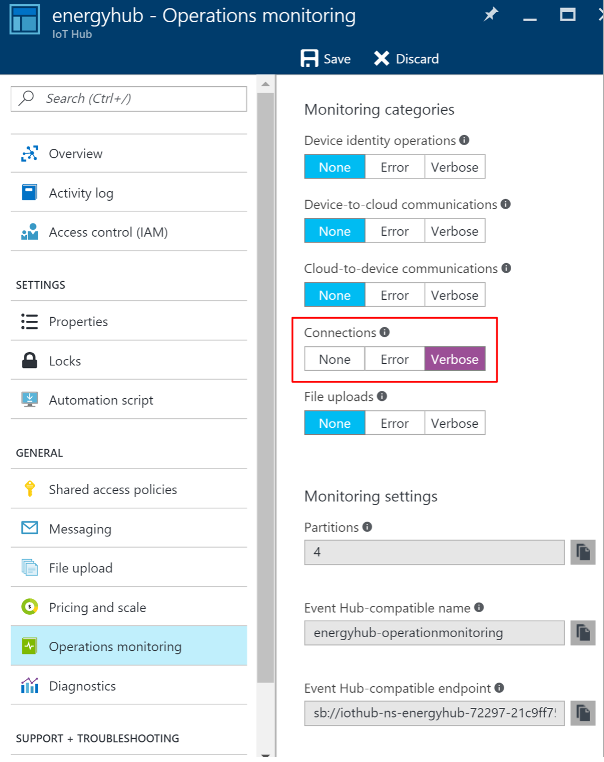
5. Click **Save**.

### Task 2: Collect device connection telemetry with the hot path Stream Analytics job

Now that the device connections are being logged, update your hot path Stream Analytics job (the first one you created) with a new input that ingests device telemetry from Operations Monitoring. Next, create a query that joins all connected and disconnected events with a DATEDIFF function that only returns devices with a disconnect event, but no reconnect event within 120 seconds. Output the events to Power BI.

1. In your browser, navigate to the **Azure Portal** (<https://portal.azure.com)>.
2. Open the hot path Stream Analytics job (the first one you created).
3. Stop the job if it is currently running, from the Overview blade.
4. Go to **Inputs** for your Stream Analytics job and add an input connected to your IoT Hub.
   1. Click on **Inputs** under JOB TOPOLOGY, or click the Inputs box on the Overview blade.  
      
   2. On the **Inputs** blade, click **Add** in the **command bar** at the top.



* 1. Configure the **Input settings** as follows:
     1. Input Alias: connections
     2. Source Type: Data stream
     3. Source: **IoT hub**
     4. Subscription: Use IoT hub from current subscription
     5. IoT Hub: Select your existing IoT Hub
     6. Endpoint: **Operations monitoring**
     7. Shared Access Policy Name: Set to Service
     8. Consumer Group: Leave as $Default
     9. Event serialization format: JSON  
        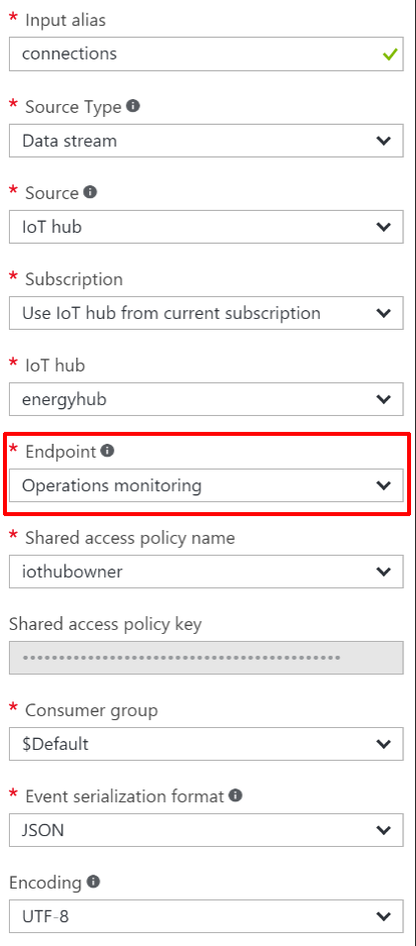
  2. Click **Create**.

1. Go to the **Outputs** blade and add the output destination for the query.
   1. Click on **Outputs** under JOB TOPOLOGY.  
      
   2. On the **Outputs** blade, click **Add** in the **command bar** at the top.



* 1. Set the **Output alias** to **powerbi-outage**.
  2. Select **Power BI** under **Sink**.
  3. Click on **Authorize** underneath Authorize Connection.

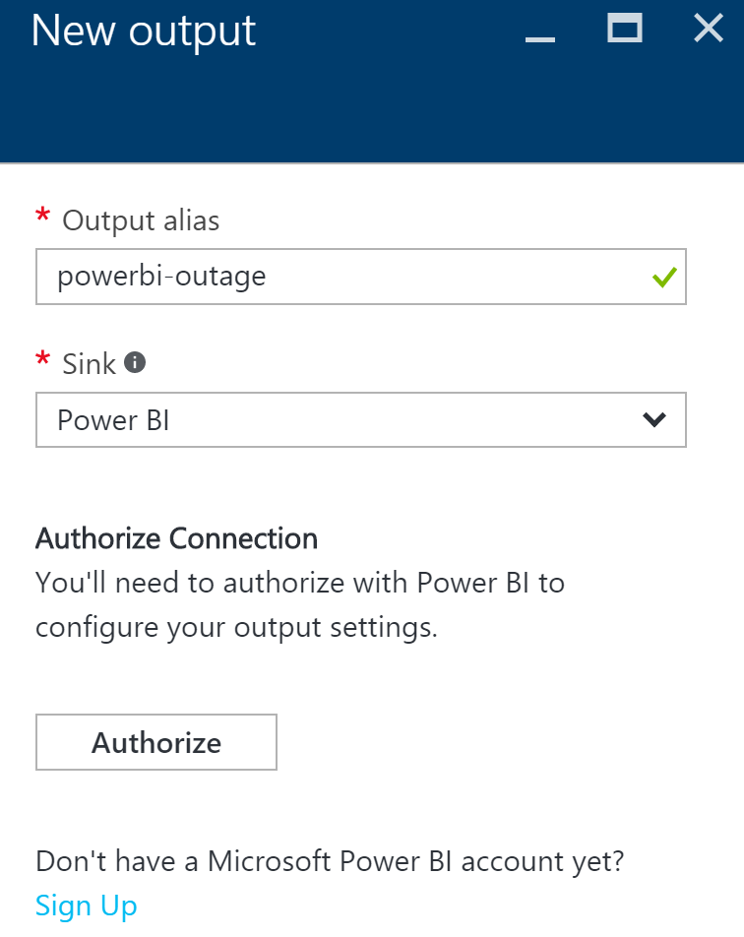

* 1. Follow the on screen prompts to log on to your Power BI account. Make sure you select **Work or school account**, since Power BI only supports organizational accounts at this time.



* 1. After authenticating, you will be taken back to the **New output** form, which will display Group Workspace: leave at My Workspace three new fields to fill out:
     1. Dataset Name: deviceoutage
     2. Table Name: deviceoutage
     3. Click on **Create**.  
        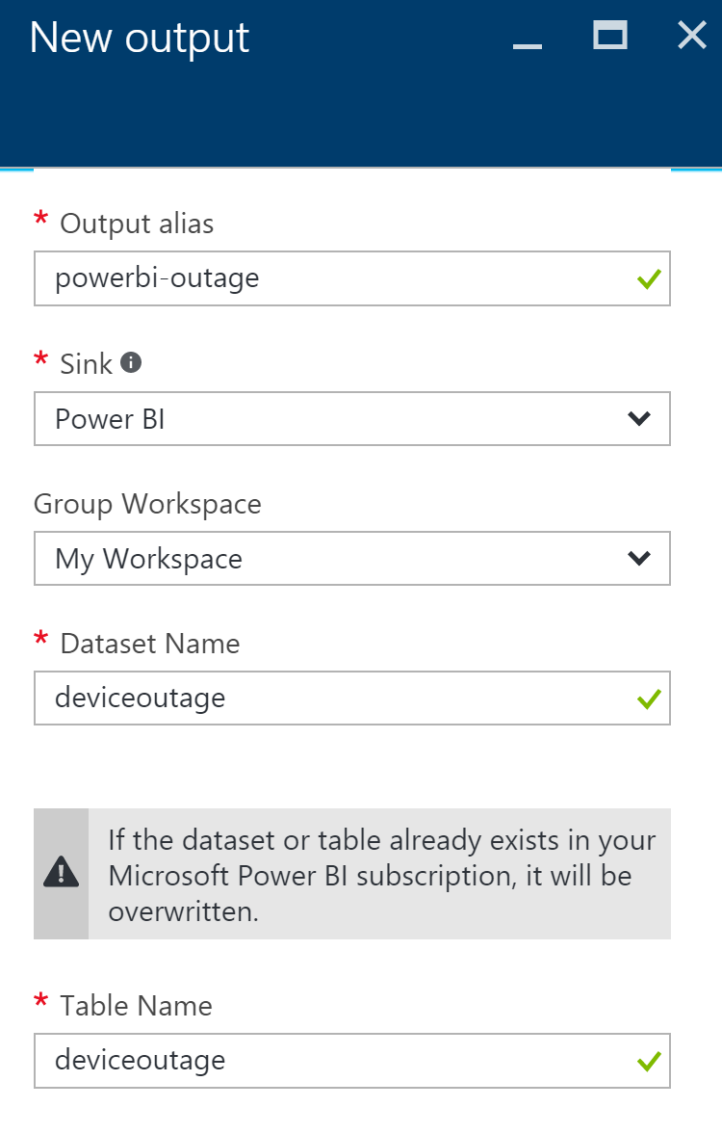

1. Go to the **Query** blade by clicking on Query under JOB TOPOLOGY.  
   
2. We will replace the hot path query, which selects the averages of the temperatures into the PowerBI output, with queries that perform the following:
   1. Select device disconnection events.
   2. Select device connection events.
   3. Join these two streams together using the Stream Analytics DATEDIFF operation on the LEFT JOIN, and then filter out any records where there was a match. This gives us devices that had a disconnect event, but no corresponding connect event within 120 seconds. Output to the Service Bus.
   4. Execute the original hot path query.
3. Replace the existing query with the following, and click **Save** in the **command bar** at the top. (Be sure to substitute in your output aliases and input aliases):

WITH

Disconnected AS (

SELECT *

FROM connections TIMESTAMP BY [Time]

WHERE OperationName = 'deviceDisconnect'

AND Category = 'Connections'

),

Connected AS (

SELECT *

FROM connections TIMESTAMP BY [Time]

WHERE OperationName = 'deviceConnect'

AND Category = 'Connections'

)

SELECT Disconnected.DeviceId, Disconnected.Time

INTO [powerbi-outage]

FROM Disconnected

LEFT JOIN Connected

ON DATEDIFF(second, Disconnected, Connected) BETWEEN 0 AND 120

AND Connected.deviceId = Disconnected.deviceId

WHERE Connected.DeviceId IS NULL;

SELECT AVG(temp) AS Average, id

INTO powerbi

FROM temps

GROUP BY TumblingWindow(minute, 5), id;

1. Go to the **Overview** blade on your **Stream Analytics job**, click **Start** in the **command bar** to begin the job.
   1. Leave the **Job output start time** setting at **Now** and click **Start**.



### Task 3: Test the device outage notifications

Register and activate a few devices on the Smart Meter Simulator, then connect them. Deactivate them without reconnecting in order for them to show up in the device outage report we will create in the next task.

1. Run the Smart Meter Simulator from Visual Studio.
2. Click the **Register** button.  
   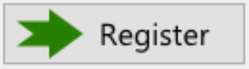
3. Click on 3 of the windows to highlight them.  
   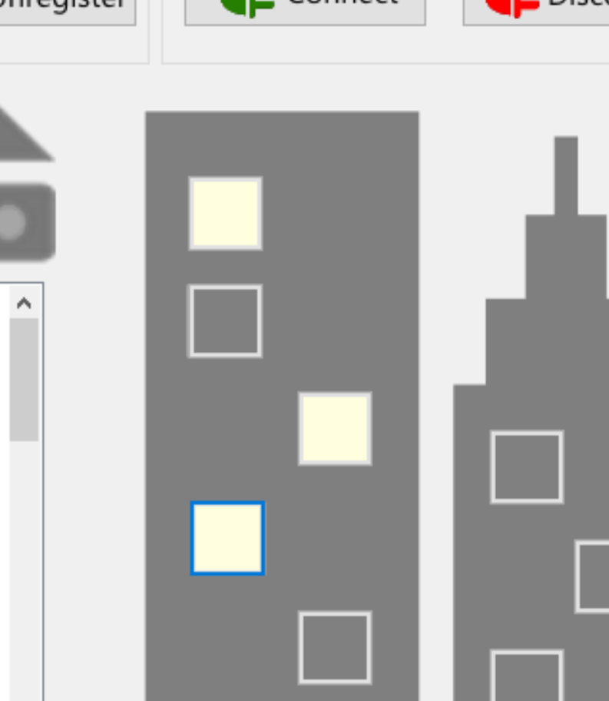
4. Click the **Activate** button.  
   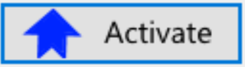
5. Click the **Connect** button.  
   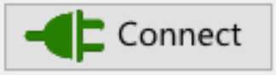
6. After a few seconds, click **Disconnect**.  
   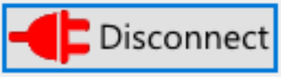
7. Click **Unregister**.  
   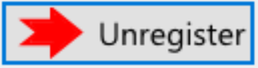
8. It may take up to 10 minutes, but you should receive 3 emails that contain the corresponding Device Id and date/time stamps of when the device was disconnected, one for each device.

### Task 4: Visualize disconnected devices with Power BI

1. Log on to **Power BI** to see if data is being collected.
2. A new dataset should appear, named **deviceoutage**. (It is starred to indicate it is new) If you do not see the dataset, you may need to connect your devices on the Smart Meter Simulator, then disconnect and unregister them and wait up to 5 minutes.

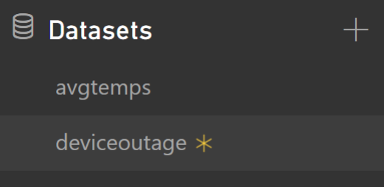

1. Click the new dataset to go the **report designer**.
2. Add a **Table visualization**.

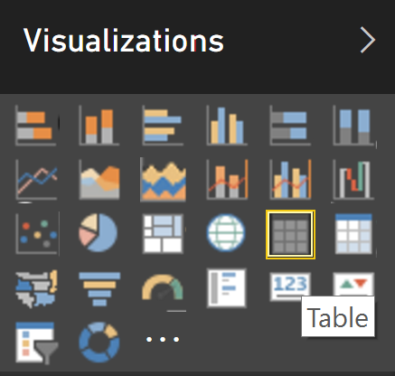

1. Select the **deviceid** and **time** fields, which will automatically be added to the table. You should see the Device Id of each of the devices you connected, and then disconnected for more than 2 minutes.  
   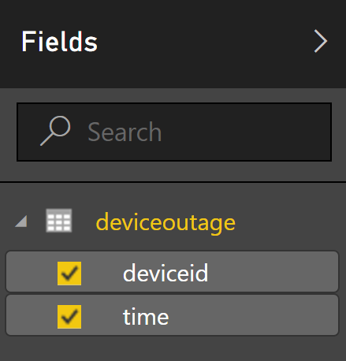  
     
   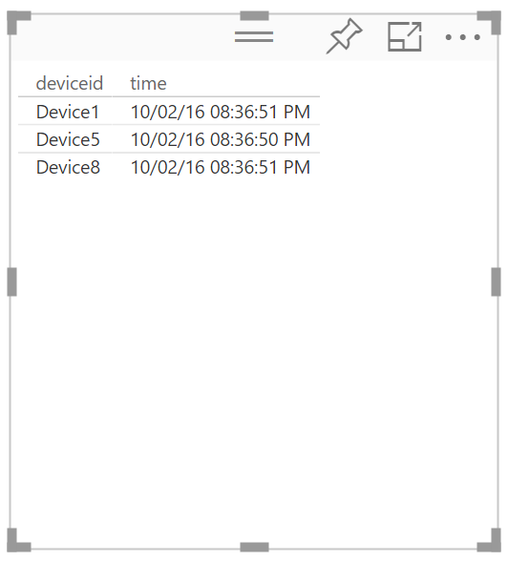
2. Save the report.



1. Switch to **Reading View**.



1. Within the report, click the column headers to sort by device or date. You may run a few more tests with the Smart Meter Simulator and periodically refresh the report to see new devices.

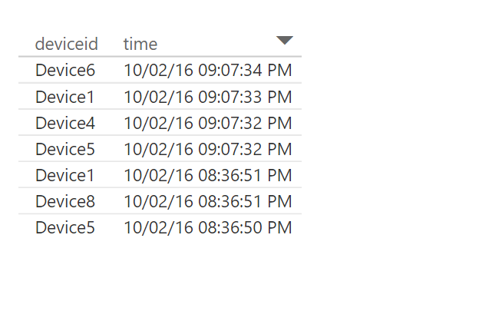

## Exercise 7: Cleanup

Duration: 10 minutes

Synopsis: In this exercise, attendees will de-provision any Azure resources that were created in support of the lab.

1. Delete the HDInsight cluster.
   1. From the Portal, navigate to the blade of your HDInsight cluster and click **Delete** in the **command bar** at the top.



* 1. When prompted to confirm the deletion, click **Yes**.

1. Delete the *two* Stream Analytics jobs.
   1. From the **Existing** **Portal**, navigate to the **Stream Analytics** tab.
   2. In the list, select the **Stream Analytics job** and click **Delete**.
   3. Confirm the prompt by clicking **Yes**.
2. Delete the IoT Hub.
   1. From the **Portal**, navigate to the blade of your IoT Hub.
   2. Click the **Delete** button in the **command** **bar**.
   3. Confirm the prompt by clicking **Yes**.